Layering Of Social Networking Account

*A*

*Report*

*Submitted in partial fulfilment of the*

*Requirements for the award of the Degree of*

**BACHELOR OF ENGINEERING**

**IN**

**INFORMATION TECHNOLOGY**

**By**

**K.Nikhil <1602-21-737-046>**

**Under the guidance of Ms B. Leelavathy**



**Department of Information Technology**

**Vasavi College of Engineering (Autonomous)**

**(Affiliated to Osmania University)**

**Ibrahimbagh, Hyderabad-31**

**2022-2023**

**BONAFIDE CERTIFICATE**

This is to certify that this project report titled

Layering Of Social Networking Account

is a project work of ***Nikhil***

bearing roll no. 1602-21-737-046

who carried out

this project under my supervision

in the IV semester

of the academic year 2022- 2023

Signature Signature

External Examiner Internal Examiner

**DATABASEMANAGEMENT SYSTEM**

PROJECT TITLE: ’ LayeringOfSocialNetworkingAccount’

**ABSTARCT**:

The integration of multiple social networking applications through a single login is a topic of great interest in the current era of social media. In this context, the aim of this study is to propose a solution for integrating various social networking applications related to a user through a single login. The proposed solution involves the development of an application programming interface (API) that allows third-party applications to interact with the user's preferred social media platform. This API can then be used to seamlessly integrate multiple social networking applications and provide a unified login experience to the user. The proposed solution is expected to significantly enhance the usability of social networking applications and simplify the user's social media experience.

**REQUIREMENTS:**

Over all 5 tables are required for the ER model representation, they are:

1.User

2.Social Media Platform

3.Third-Party Application

4.User-Social Media Platform Mapping

5.Social Media Posts

**Table 1: USERS**

**Attributes**

* **User_ID (primary key)**
* **Name (string)**
* **Email (string)**
* **Password (string)**
* **DateOfBirth (date)**

**constraints:**

primary key:user_id

**Table 2: Social Media Platform**

**Attributes:**

* Platform_ID (primary key)
* Name (string)
* URL (string)

**Constraints:**

-prinmary key:platform_ID

**Table 3:** **Third-Party Application**

**Attributes:**

* **App_ID (primary key)**
* **Name (string)**
* **URL (string)**
* **Description (text)**

**Constraints:**

Primary key: app_id

**Table 4:** **User-Social Media Platform Mapping**

**Attributes:**

* **Mapping_ID (primary key)**
* **User_ID (foreign key)**
* **Platform_ID (foreign key)**
* **Handle (string)**

**Constarints:**

Primary key:Mapping _ID

Foreign key:user_id,Platform_ID

**Table 5:** **Social Media Posts**

**Attributes:**

* **Post_ID (primary key)**
* **User_ID (foreign key)**
* **Platform_ID (foreign key)**
* **Content (text)**
* **Timestamp (datetime)**

**Constraints:**

Primary key:Post_ID;

Foreign key:user_id,Platfrom_ID;

**Mapping Cardinalities:**

* **One user can have many social media platform mappings (one-to-many relationship: User-Social Media Platform Mapping).**
* **One user can have many social media posts (one-to-many relationship: User-Social Media Posts)**
* **Many social media platforms can have many social media posts (many-to-many relationship: Social Media Platform-Posts)**
* **One social media platform mapping can only be associated with one social media platform (one-to-one relationship: User-Social Media Platform Mapping-Social Media Platform).**

**ER DAIGRAM:**

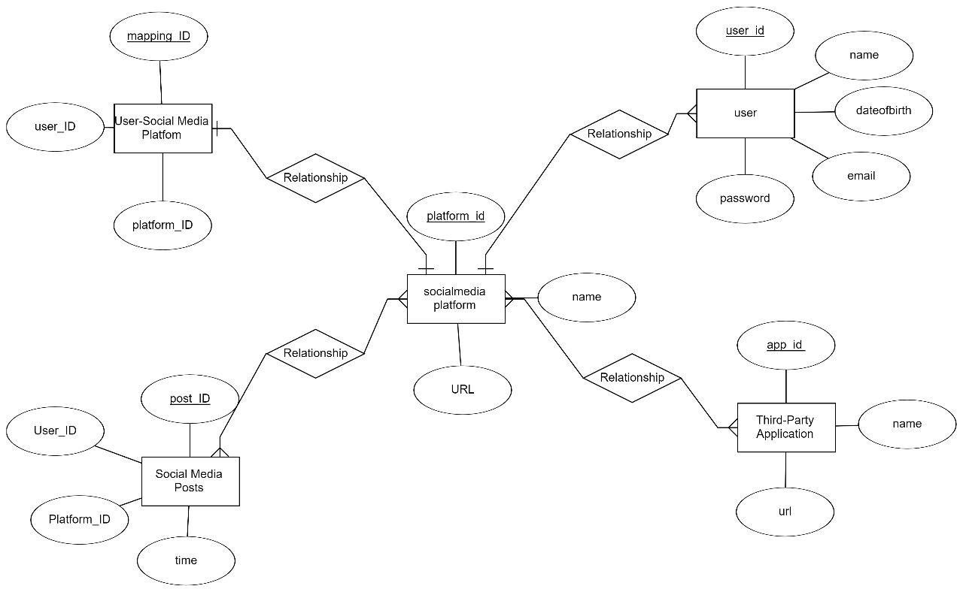

**DDL COMMANDS:**

**USER TABLE:**

**a)create():**

**create table users(**

**2 user_id number,**

**3 name varchar(50),**

**4 email varchar(50),**

**5 dateofbirth number,**

**6 primary key(user_id));**

Table created.

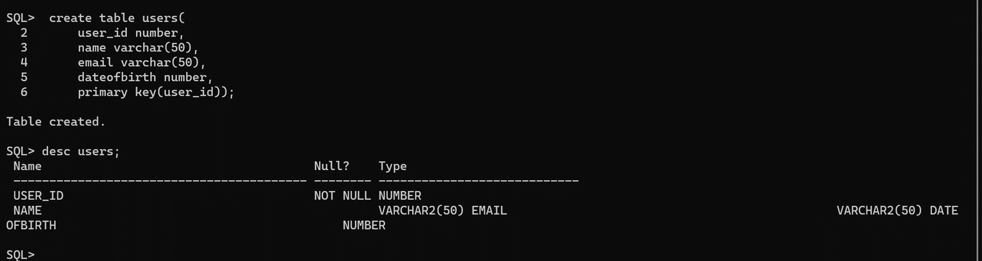

**Social_media_platfrom:**

SQL> create table social_media_platform(

2 platform_id number,

3 name varchar(50),

4 url varchar(50),

5 primary key(platform_id));

Table created.

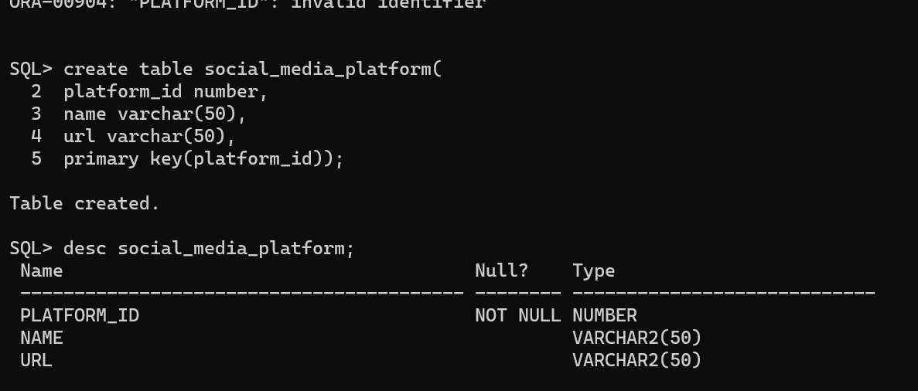

**Third party:**

SQL> create table third_party(

2 app_id number,

3 name varchar(50),

4 url varchar(50),

5 primary key(app_id));

Table created.

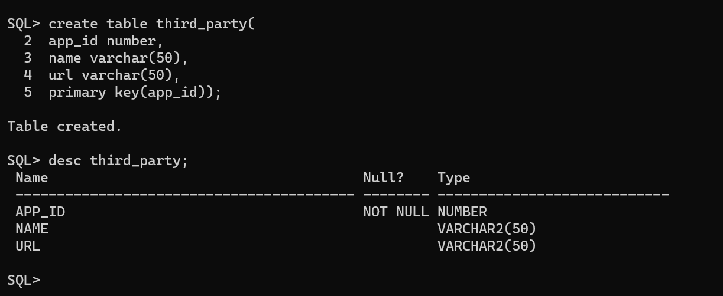

**User_social_media Table:**

**create table user_social_media(**

**2 mapping_id number,**

**3 user_id number,**

**4 platfrom_id number,**

**5 primary key(mapping_id));**

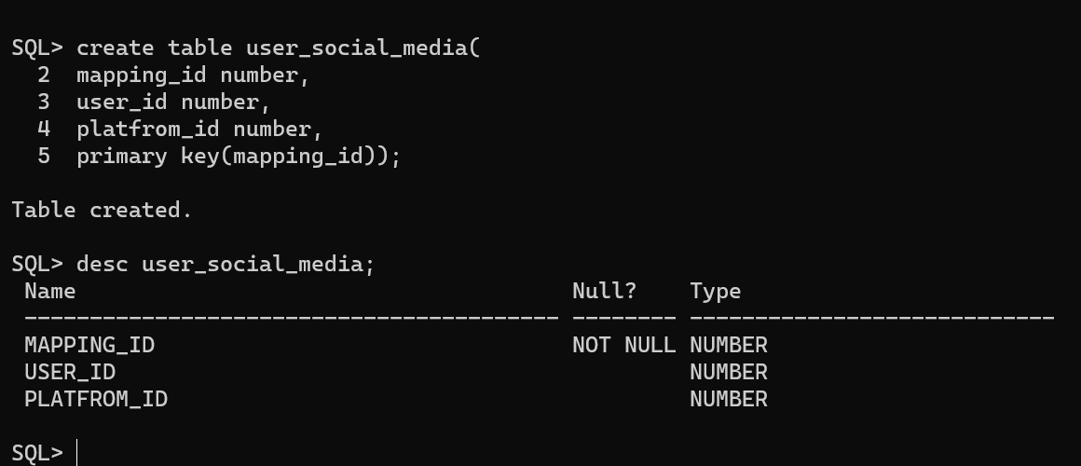

**Posts table:**

**SQL> create table posts(**

**2 post_id number,**

**3 user_id number,**

**4 platfrom_id number,**

**5 time number,**

**6 primary key(post_id));**

**Table created.**

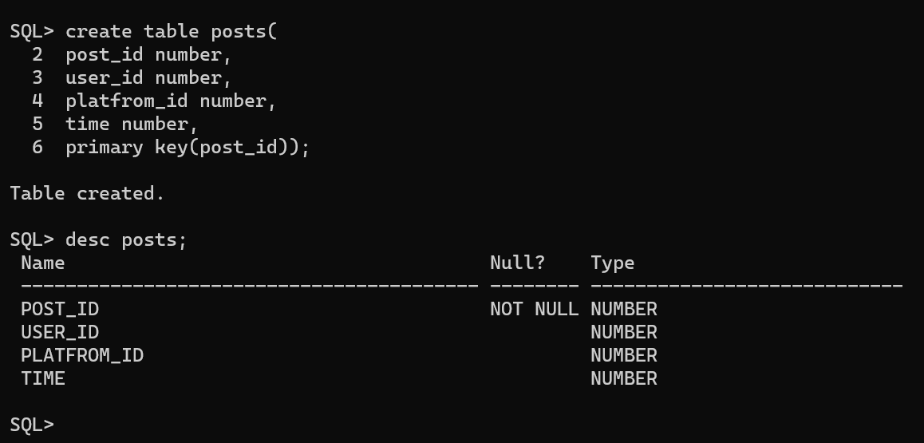

**DML COMMANDS:**

**USERS TABLE:**

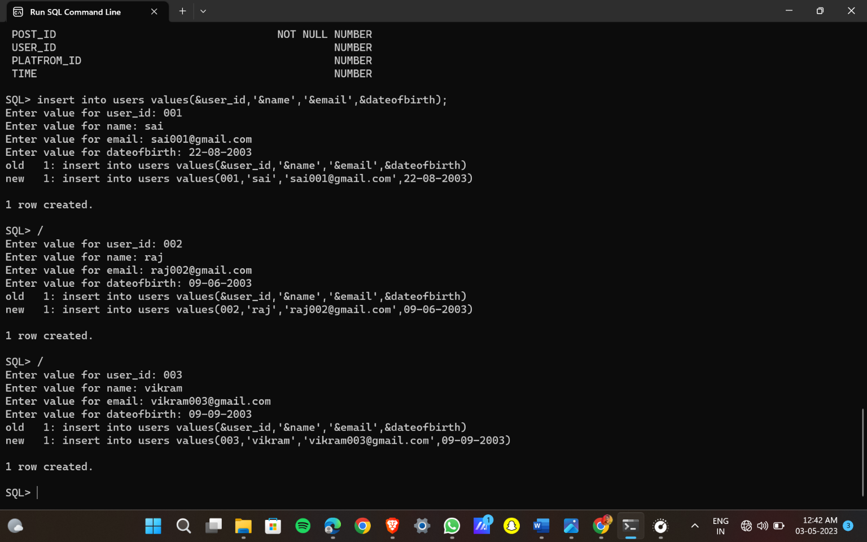

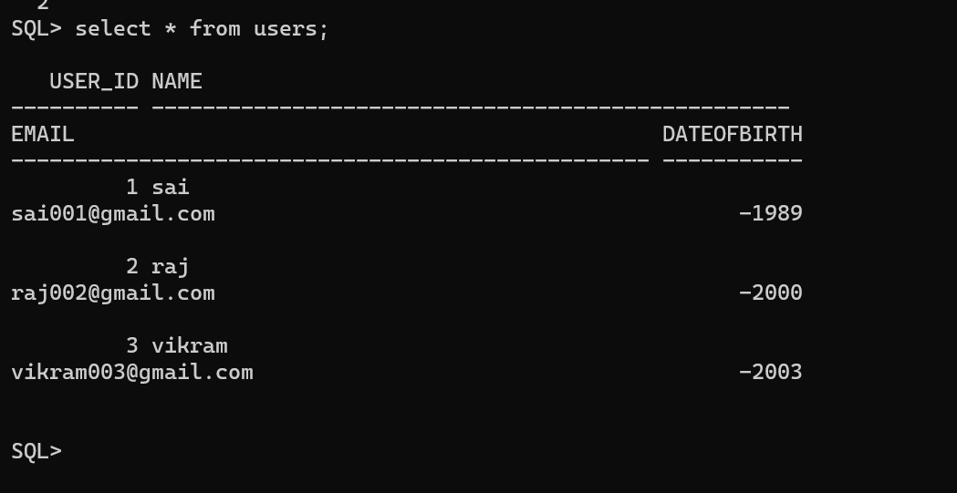

**SOCIAL_MEDIA_PLATFORM:**

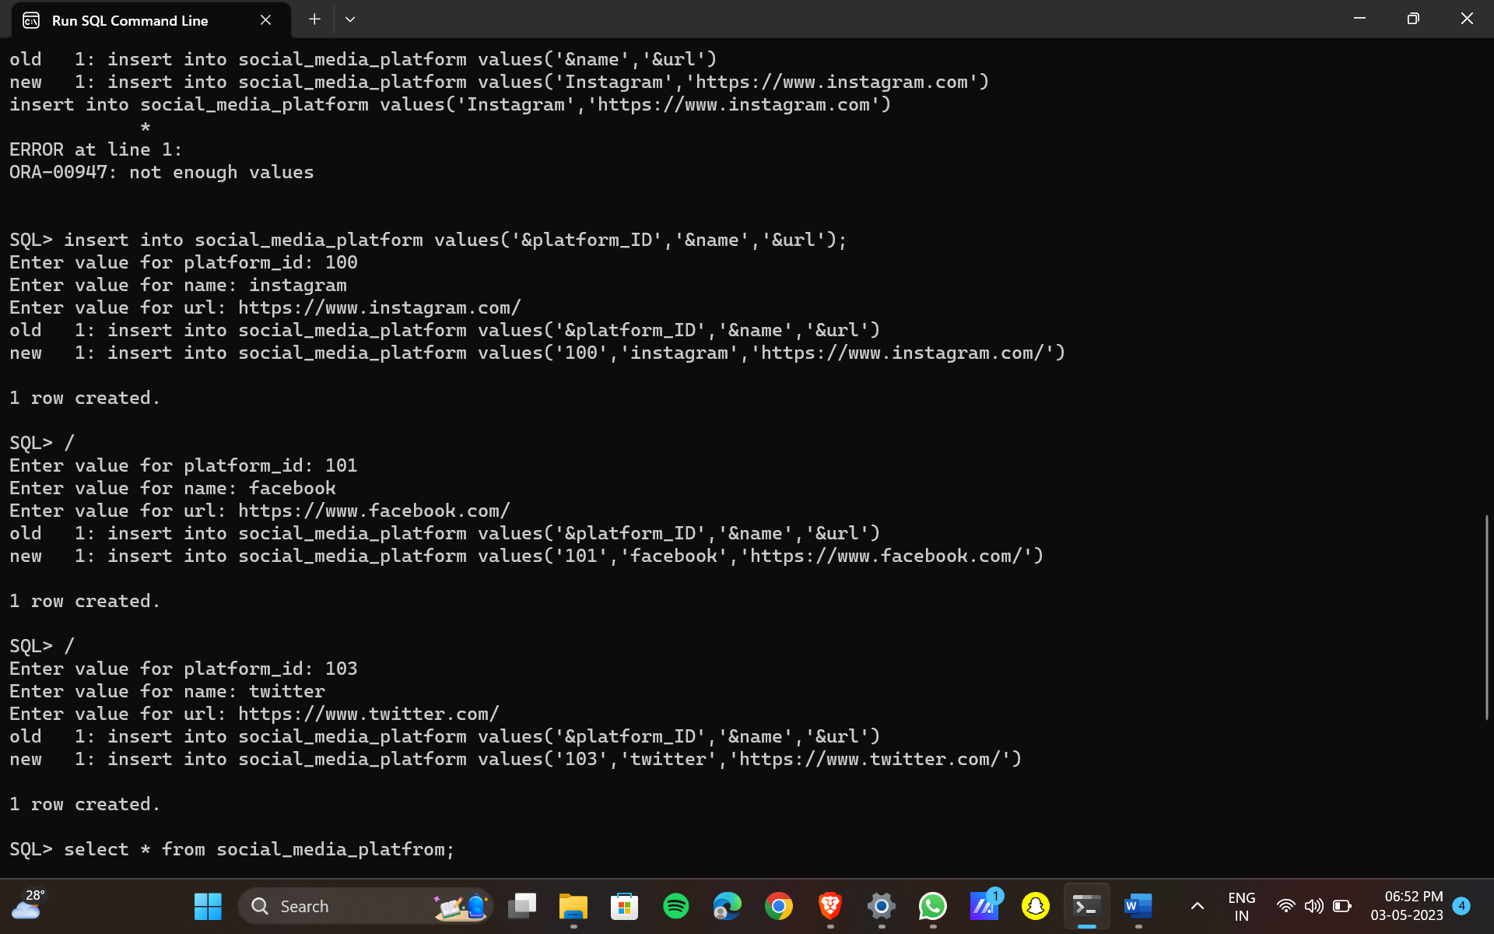

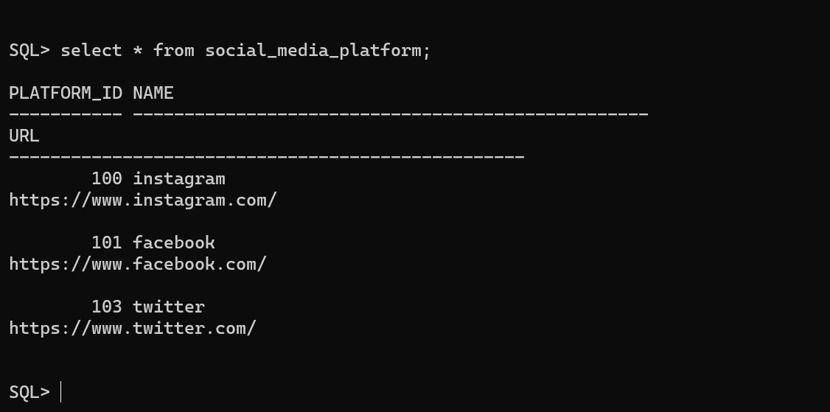

**Third party :**

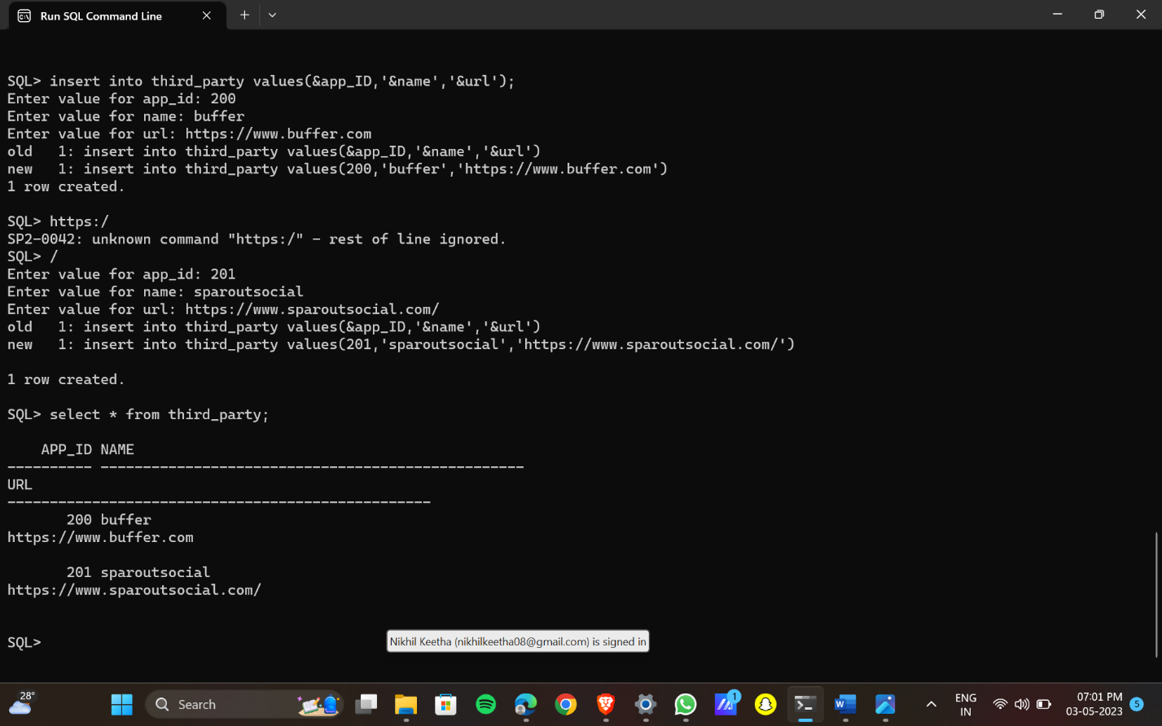

**User social media:**

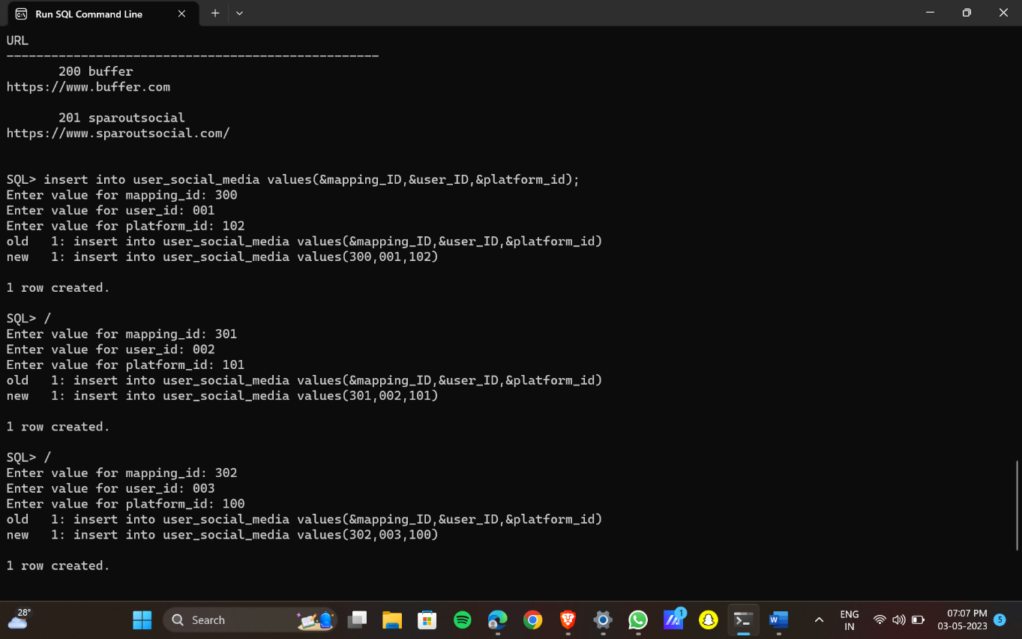

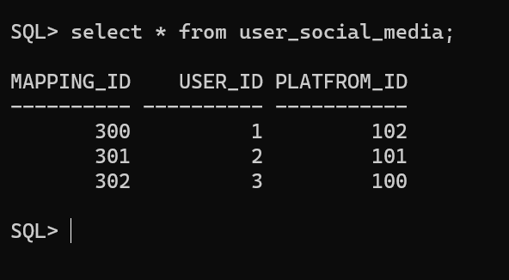

Posts :

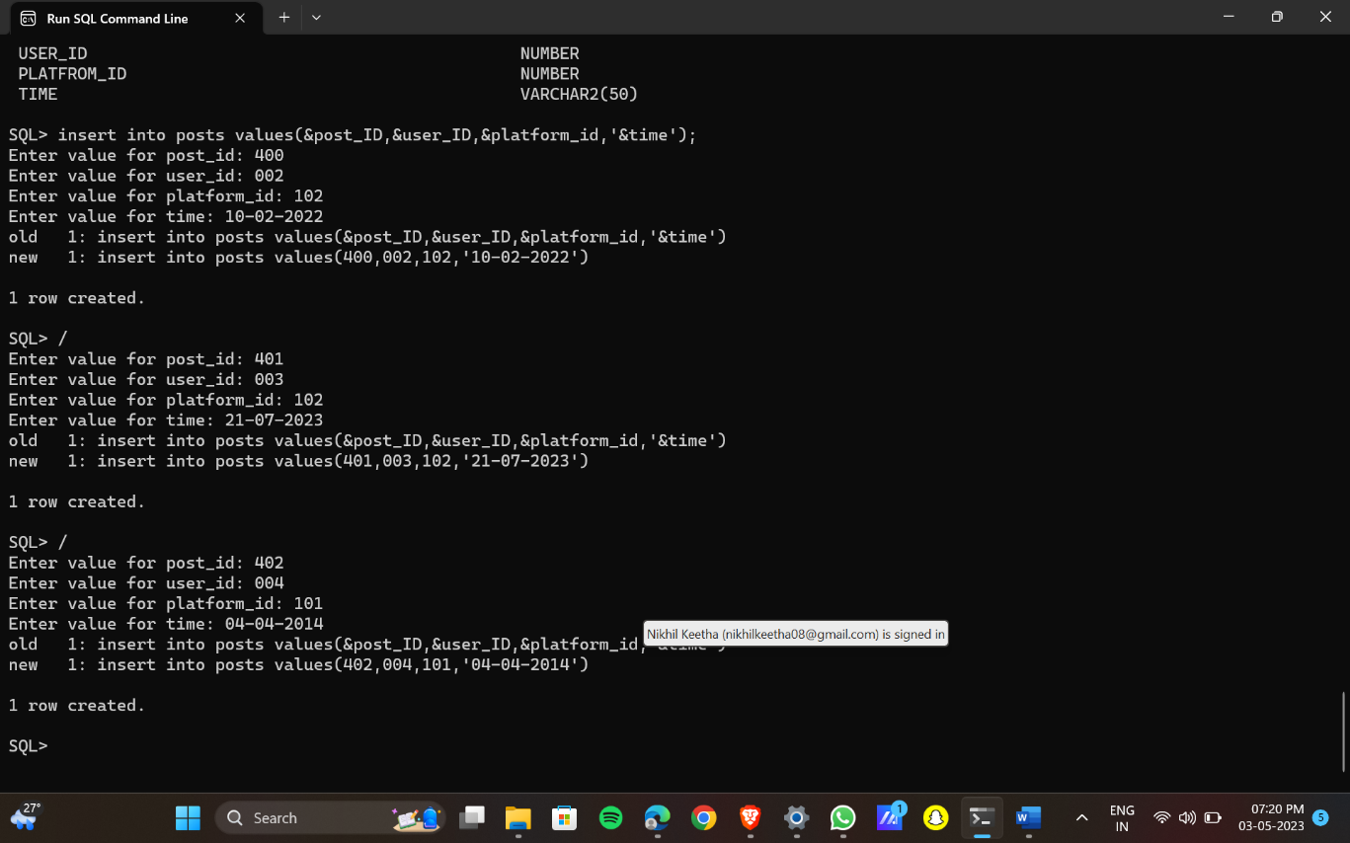

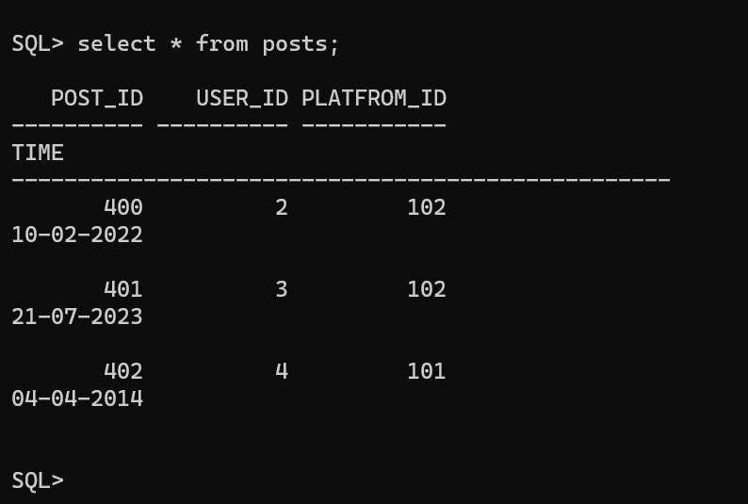

**IMPLEMENTATION**

**JAVA- SQL Connectivity using JDBC:**

**Java Database Connectivity (JDBC)** is an application programming interface (API) for the programming language Java, which defines how a client may access a database. It is a Java-based data access technology used for Java database connectivity. It is part of the Java Standard Edition platform, from Oracle Corporation. It provides methods to query and update data in a database and is oriented towards relational databases.

The connection to the database can be performed using Java programming (JDBC API) as:

import java.sql.Connection;

import java.sql.DriverManager;

import java.sql.Statement;

public class connection {

public static void main(String args[])

{

try {

Class.forName("oracle.jdbc.driver.OracleDriver");

Connection con=DriverManager.getConnection("jdbc:oracle:thin:@localhost:1521:xe","Nikhil","Nikhil");

Statement smt=con.createStatement();

smt.executeUpdate("create table emp(eno number,ename varchar(12))");

System.out.println("yes");

con.close();

}

catch(Exception e)

{

System.out.println(e);

}

}

**Main Page:**

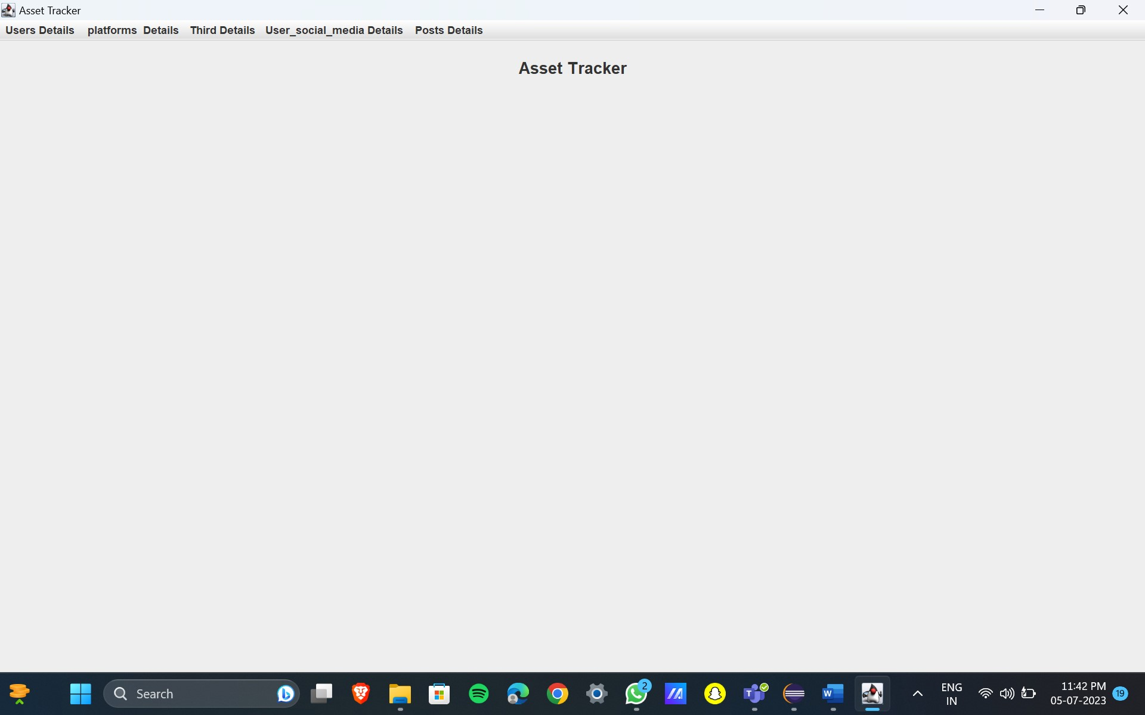

import javax.swing.*;

import java.awt.*;

import java.awt.event.*;

public class MainPage extends JFrame {

/*

*

*/

private static final long **serialVersionUID** = 1L;

//private JButton retrieveMarksButton;

public MainPage() {

// Set frame properties

setTitle("Asset Tracker");

setDefaultCloseOperation(JFrame.**EXIT_ON_CLOSE**);

// Create label

JLabel welcomeLabel = new JLabel("Asset Tracker");

welcomeLabel.setFont(new Font("Arial", Font.**BOLD**, 18));

welcomeLabel.setHorizontalAlignment(SwingConstants.**CENTER**);

welcomeLabel.setBorder(BorderFactory.createEmptyBorder(20, 0, 20, 0));

add(welcomeLabel, BorderLayout.**NORTH**);

// Create panel for the button

/*JPanel buttonPanel = new JPanel();

retrieveMarksButton = new JButton("Retrieve Marks");

buttonPanel.add(retrieveMarksButton);

*/

// Create menu bar

JMenuBar menuBar = new JMenuBar();

// Create menus

JMenu UsersMenu = new JMenu("Users Details");

JMenu platformsMenu = new JMenu(" platforms Details");

JMenu ThirdMenu = new JMenu("Third Details");

JMenu User_social_mediaMenu = new JMenu("User_social_media Details");

JMenu PostsMenu = new JMenu("Posts Details");

// Create menu item for student menu

JMenuItem viewUsersDetails = new JMenuItem("View User Details");

viewUsersDetails.addActionListener(new ActionListener() {

public void actionPerformed(ActionEvent e) {

new Users();

}

});

// Create menu item for course menu

JMenuItem viewplatformsDetails = new JMenuItem("View platforms Details");

viewplatformsDetails.addActionListener(new ActionListener() {

public void actionPerformed(ActionEvent e) {

new platforms();

}

// Create menu item for enrollment menu

JMenuItem viewThirdDetails = new JMenuItem("View Third Details");

viewThirdDetails.addActionListener(new ActionListener() {

public void actionPerformed(ActionEvent e) {

new Third();

}

});

// Create menu item for semester menu

JMenuItem viewUser_social_mediaDetails = new JMenuItem("View User_social_media Details");

viewUser_social_mediaDetails.addActionListener(new ActionListener() {

public void actionPerformed(ActionEvent e) {

new User_social_media();

}

});

// Create menu item for grade menu

JMenuItem viewpostsDetails = new JMenuItem("View Posts Details");

viewpostsDetails.addActionListener(new ActionListener() {

public void actionPerformed(ActionEvent e) {

new Posts();

}

});

// Add menu items to respective menus

UsersMenu.add(viewUsersDetails);

platformsMenu.add(viewplatformsDetails);

ThirdMenu.add(viewThirdDetails);

User_social_mediaMenu.add(viewUser_social_mediaDetails);

PostsMenu.add(viewpostsDetails);

// Add menus to the menu bar

menuBar.add(UsersMenu);

menuBar.add(platformsMenu);

menuBar.add(ThirdMenu);

menuBar.add(User_social_mediaMenu);

menuBar.add(PostsMenu);

// Set the menu bar

setJMenuBar(menuBar);

// Add the button panel to the frame

// add(buttonPanel, BorderLayout.CENTER);

// Set button action for "Retrieve Marks"

/*retrieveMarksButton.addActionListener(new ActionListener() {

public void actionPerformed(ActionEvent e) {

new Retreive();

}

});*/

// Add window listener to handle maximizing the window

addWindowStateListener(new WindowStateListener() {

public void windowStateChanged(WindowEvent e) {

if ((e.getNewState() & Frame.**MAXIMIZED_BOTH**) == Frame.**MAXIMIZED_BOTH**) {

System.**out**.println("Window maximized");

} else {

System.**out**.println("Window not maximized");

}

}

});

// Set frame size and visibility

setSize(800, 600);

setVisible(true);

}

public static void main(String[] args) {

new MainPage();

}

}

USERS page :

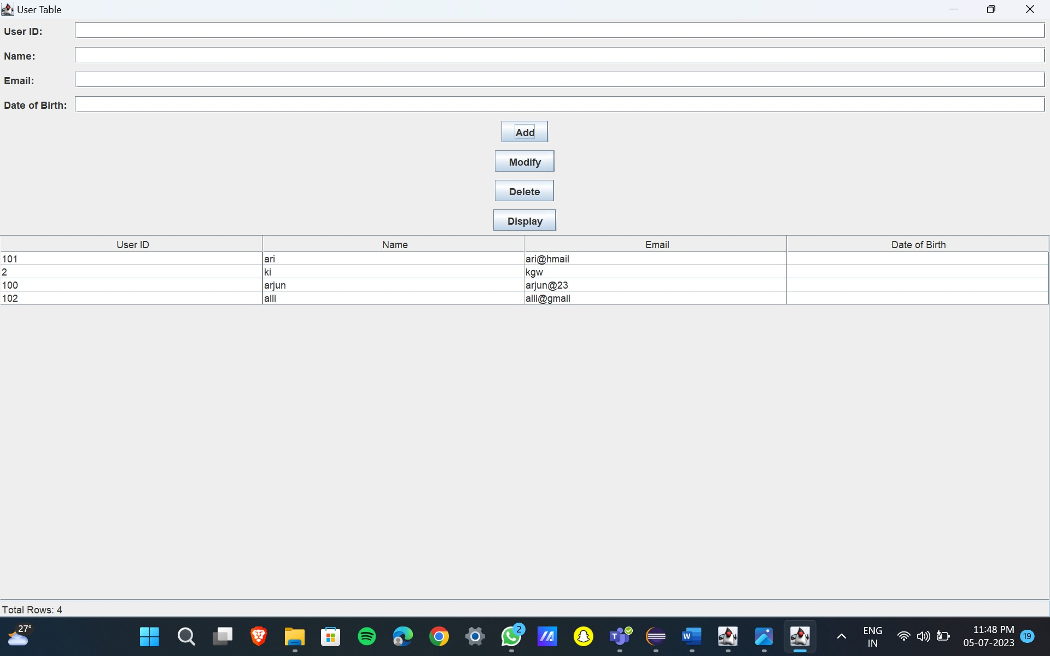

import javax.swing.*;

import javax.swing.table.DefaultTableModel;

import java.awt.*;

import java.sql.*;

import java.util.ArrayList;

import java.util.List;

public class Users extends JFrame {

private JTextField txtUserId, txtName, txtEmail, txtDateOfBirth, txtTotalRows;

private JTable tblUsers;

private JButton btnAdd, btnModify, btnDelete, btnDisplay;

private Connection connection;

public Users() {

initializeUI();

connectToDatabase();

displayUsers();

generateTotalRows();

}

private void initializeUI() {

txtUserId = new JTextField();

txtName = new JTextField();

txtEmail = new JTextField();

txtDateOfBirth = new JTextField();

tblUsers = new JTable();

tblUsers.setSelectionMode(ListSelectionModel.SINGLE_SELECTION);

tblUsers.getSelectionModel().addListSelectionListener(e -> selectUser());

JScrollPane scrollPane = new JScrollPane(tblUsers);

btnAdd = new JButton("Add");

btnModify = new JButton("Modify");

btnDelete = new JButton("Delete");

btnDisplay = new JButton("Display");

txtTotalRows = new JTextField();

txtTotalRows.setEditable(false);

JPanel panel = new JPanel(new GridBagLayout());

GridBagConstraints gbc = new GridBagConstraints();

gbc.gridx = 0;

gbc.gridy = 0;

gbc.anchor = GridBagConstraints.WEST;

gbc.insets = new Insets(5, 5, 5, 5);

panel.add(new JLabel("User ID:"), gbc);

gbc.gridy++;

panel.add(new JLabel("Name:"), gbc);

gbc.gridy++;

panel.add(new JLabel("Email:"), gbc);

gbc.gridy++;

panel.add(new JLabel("Date of Birth:"), gbc);

gbc.gridx = 1;

gbc.gridy = 0;

gbc.fill = GridBagConstraints.HORIZONTAL;

gbc.weightx = 1;

panel.add(txtUserId, gbc);

gbc.gridy++;

panel.add(txtName, gbc);

gbc.gridy++;

panel.add(txtEmail, gbc);

gbc.gridy++;

panel.add(txtDateOfBirth, gbc);

gbc.gridx = 0;

gbc.gridy++;

gbc.gridwidth = 2;

gbc.fill = GridBagConstraints.NONE;

gbc.anchor = GridBagConstraints.CENTER;

gbc.weightx = 0;

panel.add(btnAdd, gbc);

gbc.gridy++;

panel.add(btnModify, gbc);

gbc.gridy++;

panel.add(btnDelete, gbc);

gbc.gridy++;

panel.add(btnDisplay, gbc);

setLayout(new BorderLayout());

add(panel, BorderLayout.NORTH);

add(scrollPane, BorderLayout.CENTER);

add(txtTotalRows, BorderLayout.SOUTH);

btnAdd.addActionListener(e -> addUser());

btnModify.addActionListener(e -> modifyUser());

btnDelete.addActionListener(e -> deleteUser());

btnDisplay.addActionListener(e -> displayUsers());

setTitle("User Table");

pack();

setLocationRelativeTo(null);

setVisible(true);

}

private void connectToDatabase() {

String url = "jdbc:oracle:thin:@localhost:1521:xe";

String username = "Nikhil";

String password = "Nikhil";

try {

connection = DriverManager.getConnection(url, username, password);

} catch (SQLException e) {

e.printStackTrace();

}

}

private void addUser() {

String userId = txtUserId.getText();

String name = txtName.getText();

String email = txtEmail.getText();

String dateOfBirth = txtDateOfBirth.getText();

try {

String query = "INSERT INTO users (user_id, name, email, dateofbirth) VALUES (?, ?, ?, ?)";

PreparedStatement statement = connection.prepareStatement(query);

statement.setString(1, userId);

statement.setString(2, name);

statement.setString(3, email);

statement.setString(4, dateOfBirth);

statement.executeUpdate();

clearFields();

displayUsers();

generateTotalRows();

} catch (SQLException e) {

e.printStackTrace();

}

}

private void modifyUser() {

int selectedRow = tblUsers.getSelectedRow();

if (selectedRow >= 0) {

String userId = txtUserId.getText();

String name = txtName.getText();

String email = txtEmail.getText();

String dateOfBirth = txtDateOfBirth.getText();

try {

String query = "UPDATE users SET name=?, email=?, dateofbirth=? WHERE user_id=?";

PreparedStatement statement = connection.prepareStatement(query);

statement.setString(1, name);

statement.setString(2, email);

statement.setString(3, dateOfBirth);

statement.setString(4, userId);

statement.executeUpdate();

clearFields();

displayUsers();

} catch (SQLException e) {

e.printStackTrace();

}

} else {

JOptionPane.showMessageDialog(this, "Please select a user to modify.");

}

}

private void deleteUser() {

int selectedRow = tblUsers.getSelectedRow();

if (selectedRow >= 0) {

String userId = tblUsers.getValueAt(selectedRow, 0).toString();

int option = JOptionPane.showConfirmDialog(this, "Are you sure you want to delete this user?", "Confirmation", JOptionPane.YES_NO_OPTION);

if (option == JOptionPane.YES_OPTION) {

try {

String query = "DELETE FROM users WHERE user_id=?";

PreparedStatement statement = connection.prepareStatement(query);

statement.setString(1, userId);

statement.executeUpdate();

clearFields();

displayUsers();

generateTotalRows();

} catch (SQLException e) {

e.printStackTrace();

}

}

} else {

JOptionPane.showMessageDialog(this, "Please select a user to delete.");

}

}

private void displayUsers() {

try {

String query = "SELECT * FROM users";

Statement statement = connection.createStatement();

ResultSet resultSet = statement.executeQuery(query);

List<User> users = new ArrayList<>();

while (resultSet.next()) {

String userId = resultSet.getString("user_id");

String name = resultSet.getString("name");

String email = resultSet.getString("email");

String dateOfBirth = resultSet.getString("dateofbirth");

users.add(new User(userId, name, email, dateOfBirth));

}

DefaultTableModel model = new DefaultTableModel();

model.setColumnIdentifiers(new String[]{"User ID", "Name", "Email", "Date of Birth"});

for (User user : users) {

model.addRow(new String[]{user.getUserId(), user.getName(), user.getEmail(), user.getDateOfBirth()});

}

tblUsers.setModel(model);

} catch (SQLException e) {

e.printStackTrace();

}

}

private void selectUser() {

int selectedRow = tblUsers.getSelectedRow();

if (selectedRow >= 0) {

String userId = tblUsers.getValueAt(selectedRow, 0).toString();

String name = tblUsers.getValueAt(selectedRow, 1).toString();

String email = tblUsers.getValueAt(selectedRow, 2).toString();

String dateOfBirth = tblUsers.getValueAt(selectedRow, 3).toString();

txtUserId.setText(userId);

txtName.setText(name);

txtEmail.setText(email);

txtDateOfBirth.setText(dateOfBirth);

}

}

private void clearFields() {

txtUserId.setText("");

txtName.setText("");

txtEmail.setText("");

txtDateOfBirth.setText("");

}

private void generateTotalRows() {

int totalRows = tblUsers.getRowCount();

txtTotalRows.setText("Total Rows: " + totalRows);

}

public static void main(String[] args) {

SwingUtilities.invokeLater(Users::new);

}

private class User {

private String userId;

private String name;

private String email;

private String dateOfBirth;

public User(String userId, String name, String email, String dateOfBirth) {

this.userId = userId;

this.name = name;

this.email = email;

this.dateOfBirth = dateOfBirth;

}

public String getUserId() {

return userId;

}

public String getName() {

return name;

}

public String getEmail() {

return email;

}

public String getDateOfBirth() {

return dateOfBirth;

}

}

}

Platforms page:

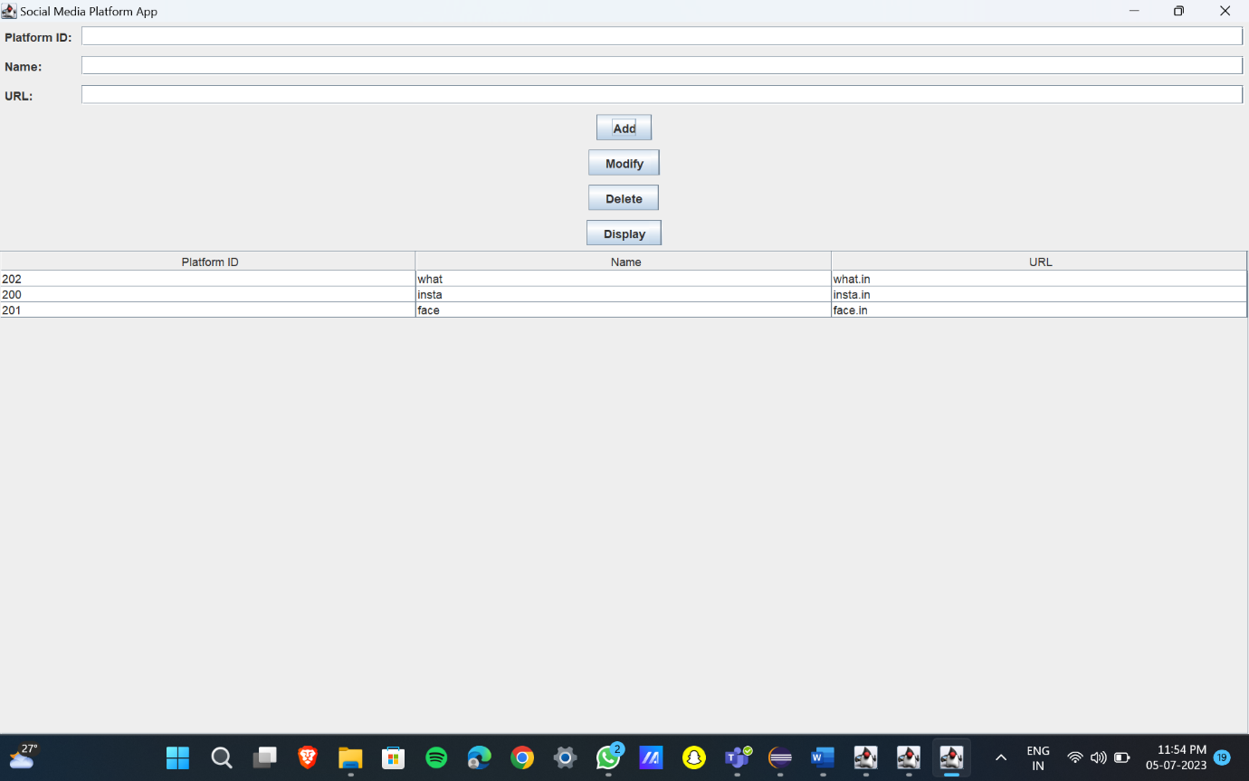

import javax.swing.table.DefaultTableModel;

import java.awt.*;

import java.sql.*; import javax.swing.*;

import java.util.ArrayList;

import java.util.List;

public class platforms extends JFrame {

private JTextField txtPlatformId, txtName, txtURL;

private JTable tblPlatforms;

private JButton btnAdd, btnModify, btnDelete, btnDisplay;

private Connection connection;

public platforms() {

initializeUI();

connectToDatabase();

displayPlatforms();

}

private void initializeUI() {

txtPlatformId = new JTextField();

txtName = new JTextField();

txtURL = new JTextField();

tblPlatforms = new JTable();

tblPlatforms.setSelectionMode(ListSelectionModel.SINGLE_SELECTION);

tblPlatforms.getSelectionModel().addListSelectionListener(e -> selectPlatform());

JScrollPane scrollPane = new JScrollPane(tblPlatforms);

btnAdd = new JButton("Add");

btnModify = new JButton("Modify");

btnDelete = new JButton("Delete");

btnDisplay = new JButton("Display");

JPanel panel = new JPanel(new GridBagLayout());

GridBagConstraints gbc = new GridBagConstraints();

gbc.gridx = 0;

gbc.gridy = 0;

gbc.anchor = GridBagConstraints.WEST;

gbc.insets = new Insets(5, 5, 5, 5);

panel.add(new JLabel("Platform ID:"), gbc);

gbc.gridy++;

panel.add(new JLabel("Name:"), gbc);

gbc.gridy++;

panel.add(new JLabel("URL:"), gbc);

gbc.gridx = 1;

gbc.gridy = 0;

gbc.fill = GridBagConstraints.HORIZONTAL;

gbc.weightx = 1;

panel.add(txtPlatformId, gbc);

gbc.gridy++;

panel.add(txtName, gbc);

gbc.gridy++;

panel.add(txtURL, gbc);

gbc.gridx = 0;

gbc.gridy++;

gbc.gridwidth = 2;

gbc.fill = GridBagConstraints.NONE;

gbc.anchor = GridBagConstraints.CENTER;

gbc.weightx = 0;

panel.add(btnAdd, gbc);

gbc.gridy++;

panel.add(btnModify, gbc);

gbc.gridy++;

panel.add(btnDelete, gbc);

gbc.gridy++;

panel.add(btnDisplay, gbc);

setLayout(new BorderLayout());

add(panel, BorderLayout.NORTH);

add(scrollPane, BorderLayout.CENTER);

btnAdd.addActionListener(e -> insertPlatform());

btnModify.addActionListener(e -> modifyPlatform());

btnDelete.addActionListener(e -> deletePlatform());

btnDisplay.addActionListener(e -> displayPlatforms());

setTitle("Social Media Platform App");

pack();

setLocationRelativeTo(null);

setVisible(true);

}

private void connectToDatabase() {

String url = "jdbc:oracle:thin:@localhost:1521:xe";

String username = "Nikhil";

String password = "Nikhil";

try {

connection = DriverManager.getConnection(url, username, password);

} catch (SQLException e) {

e.printStackTrace();

}

}

private void insertPlatform() {

String platformId = txtPlatformId.getText();

String name = txtName.getText();

String url = txtURL.getText();

try {

String query = "INSERT INTO social_media_platform (platform_id, name, url) VALUES (?, ?, ?)";

PreparedStatement statement = connection.prepareStatement(query);

statement.setString(1, platformId);

statement.setString(2, name);

statement.setString(3, url);

statement.executeUpdate();

clearFields();

displayPlatforms();

} catch (SQLException e) {

e.printStackTrace();

}

}

private void modifyPlatform() {

int selectedRow = tblPlatforms.getSelectedRow();

if (selectedRow >= 0) {

String platformId = txtPlatformId.getText();

String name = txtName.getText();

String url = txtURL.getText();

try {

String query = "UPDATE Social_Media_Platform SET Name=?, URL=? WHERE Platform_ID=?";

PreparedStatement statement = connection.prepareStatement(query);

statement.setString(1, name);

statement.setString(2, url);

statement.setString(3, platformId);

statement.executeUpdate();

clearFields();

displayPlatforms();

} catch (SQLException e) {

e.printStackTrace();

}

} else {

JOptionPane.showMessageDialog(this, "Please select a platform to modify.");

}

}

private void deletePlatform() {

int selectedRow = tblPlatforms.getSelectedRow();

if (selectedRow >= 0) {

String platformId = tblPlatforms.getValueAt(selectedRow, 0).toString();

int option = JOptionPane.showConfirmDialog(this, "Are you sure you want to delete this platform?", "Confirmation", JOptionPane.YES_NO_OPTION);

if (option == JOptionPane.YES_OPTION) {

try {

String query = "DELETE FROM social_media_platform WHERE Platform_ID=?";

PreparedStatement statement = connection.prepareStatement(query);

statement.setString(1, platformId);

statement.executeUpdate();

clearFields();

displayPlatforms();

} catch (SQLException e) {

e.printStackTrace();

}

}

} else {

JOptionPane.showMessageDialog(this, "Please select a platform to delete.");

}

}

private void displayPlatforms() {

try {

String query = "SELECT * FROM social_media_platform";

Statement statement = connection.createStatement();

ResultSet resultSet = statement.executeQuery(query);

List<Platform> platforms = new ArrayList<>();

while (resultSet.next()) {

String platformId = resultSet.getString("Platform_ID");

String name = resultSet.getString("Name");

String url = resultSet.getString("URL");

platforms.add(new Platform(platformId, name, url));

}

DefaultTableModel model = new DefaultTableModel();

model.setColumnIdentifiers(new String[]{"Platform ID", "Name", "URL"});

for (Platform platform : platforms) {

model.addRow(new String[]{platform.getPlatformId(), platform.getName(), platform.getUrl()});

}

tblPlatforms.setModel(model);

} catch (SQLException e) {

e.printStackTrace();

}

}

private void selectPlatform() {

int selectedRow = tblPlatforms.getSelectedRow();

if (selectedRow >= 0) {

String platformId = tblPlatforms.getValueAt(selectedRow, 0).toString();

String name = tblPlatforms.getValueAt(selectedRow, 1).toString();

String url = tblPlatforms.getValueAt(selectedRow, 2).toString();

txtPlatformId.setText(platformId);

txtName.setText(name);

txtURL.setText(url);

}

}

private void clearFields() {

txtPlatformId.setText("");

txtName.setText("");

txtURL.setText("");

}

public static void main(String[] args) {

SwingUtilities.invokeLater(platforms::new);

}

private class Platform {

private String platformId;

private String name;

private String url;

public Platform(String platformId, String name, String url) {

this.platformId = platformId;

this.name = name;

this.url = url;

}

public String getPlatformId() {

return platformId;

}

public String getName() {

return name;

}

public String getUrl() {

return url;

}

}

}

Third page :

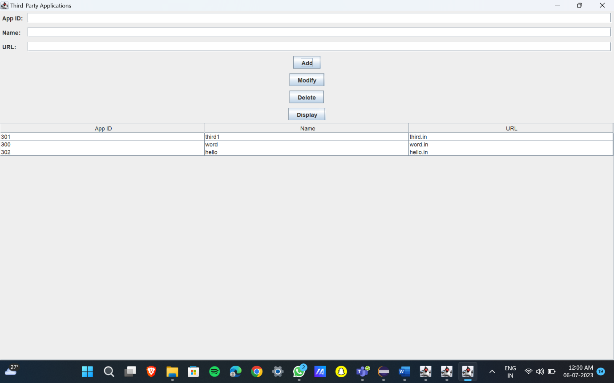

import javax.swing.*;

import javax.swing.table.DefaultTableModel;

import java.awt.*;

import java.sql.*;

import java.util.ArrayList;

import java.util.List;

public class Third extends JFrame {

private JTextField txtAppId, txtName, txtURL;

private JTable tblApplications;

private JButton btnAdd, btnModify, btnDelete, btnDisplay;

private Connection connection;

public Third() {

initializeUI();

connectToDatabase();

displayApplications();

}

private void initializeUI() {

txtAppId = new JTextField();

txtName = new JTextField();

txtURL = new JTextField();

tblApplications = new JTable();

tblApplications.setSelectionMode(ListSelectionModel.SINGLE_SELECTION);

tblApplications.getSelectionModel().addListSelectionListener(e -> selectApplication());

JScrollPane scrollPane = new JScrollPane(tblApplications);

btnAdd = new JButton("Add");

btnModify = new JButton("Modify");

btnDelete = new JButton("Delete");

btnDisplay = new JButton("Display");

JPanel panel = new JPanel(new GridBagLayout());

GridBagConstraints gbc = new GridBagConstraints();

gbc.gridx = 0;

gbc.gridy = 0;

gbc.anchor = GridBagConstraints.WEST;

gbc.insets = new Insets(5, 5, 5, 5);

panel.add(new JLabel("App ID:"), gbc);

gbc.gridy++;

panel.add(new JLabel("Name:"), gbc);

gbc.gridy++;

panel.add(new JLabel("URL:"), gbc);

gbc.gridx = 1;

gbc.gridy = 0;

gbc.fill = GridBagConstraints.HORIZONTAL;

gbc.weightx = 1;

panel.add(txtAppId, gbc);

gbc.gridy++;

panel.add(txtName, gbc);

gbc.gridy++;

panel.add(txtURL, gbc);

gbc.gridx = 0;

gbc.gridy++;

gbc.gridwidth = 2;

gbc.fill = GridBagConstraints.NONE;

gbc.anchor = GridBagConstraints.CENTER;

gbc.weightx = 0;

panel.add(btnAdd, gbc);

gbc.gridy++;

panel.add(btnModify, gbc);

gbc.gridy++;

panel.add(btnDelete, gbc);

gbc.gridy++;

panel.add(btnDisplay, gbc);

setLayout(new BorderLayout());

add(panel, BorderLayout.NORTH);

add(scrollPane, BorderLayout.CENTER);

btnAdd.addActionListener(e -> insertApplication());

btnModify.addActionListener(e -> modifyApplication());

btnDelete.addActionListener(e -> deleteApplication());

btnDisplay.addActionListener(e -> displayApplications());

setTitle("Third-Party Applications");

pack();

setLocationRelativeTo(null);

setVisible(true);

}

private void connectToDatabase() {

String url = "jdbc:oracle:thin:@localhost:1521:xe";

String username = "Nikhil";

String password = "Nikhil";

try {

connection = DriverManager.getConnection(url, username, password);

} catch (SQLException e) {

e.printStackTrace();

}

}

private void insertApplication() {

String appId = txtAppId.getText();

String name = txtName.getText();

String url = txtURL.getText();

try {

String query = "INSERT INTO Third_party(app_id, name, url) VALUES (?, ?, ?)";

PreparedStatement statement = connection.prepareStatement(query);

statement.setString(1, appId);

statement.setString(2, name);

statement.setString(3, url);

statement.executeUpdate();

clearFields();

displayApplications();

} catch (SQLException e) {

e.printStackTrace();

}

}

private void modifyApplication() {

int selectedRow = tblApplications.getSelectedRow();

if (selectedRow >= 0) {

String appId = txtAppId.getText();

String name = txtName.getText();

String url = txtURL.getText();

try {

String query = "UPDATE Third_party SET name=?, url=? WHERE app_id=?";

PreparedStatement statement = connection.prepareStatement(query);

statement.setString(1, name);

statement.setString(2, url);

statement.setString(3, appId);

statement.executeUpdate();

clearFields();

displayApplications();

} catch (SQLException e) {

e.printStackTrace();

}

} else {

JOptionPane.showMessageDialog(this, "Please select an application to modify.");

}

}

private void deleteApplication() {

int selectedRow = tblApplications.getSelectedRow();

if (selectedRow >= 0) {

String appId = tblApplications.getValueAt(selectedRow, 0).toString();

int option = JOptionPane.showConfirmDialog(this, "Are you sure you want to delete this application?", "Confirmation", JOptionPane.YES_NO_OPTION);

if (option == JOptionPane.YES_OPTION) {

try {

String query = "DELETE FROM Third_party WHERE app_id=?";

PreparedStatement statement = connection.prepareStatement(query);

statement.setString(1, appId);

statement.executeUpdate();

clearFields();

displayApplications();

} catch (SQLException e) {

e.printStackTrace();

}

}

} else {

JOptionPane.showMessageDialog(this, "Please select an application to delete.");

}

}

private void displayApplications() {

try {

String query = "SELECT * FROM Third_party";

Statement statement = connection.createStatement();

ResultSet resultSet = statement.executeQuery(query);

List<Application> applications = new ArrayList<>();

while (resultSet.next()) {

String appId = resultSet.getString("app_id");

String name = resultSet.getString("name");

String url = resultSet.getString("url");

applications.add(new Application(appId, name, url));

}

DefaultTableModel model = new DefaultTableModel();

model.setColumnIdentifiers(new String[]{"App ID", "Name", "URL"});

for (Application application : applications) {

model.addRow(new String[]{application.getAppId(), application.getName(), application.getUrl()});

}

tblApplications.setModel(model);

} catch (SQLException e) {

e.printStackTrace();

}

}

private void selectApplication() {

int selectedRow = tblApplications.getSelectedRow();

if (selectedRow >= 0) {

String appId = tblApplications.getValueAt(selectedRow, 0).toString();

String name = tblApplications.getValueAt(selectedRow, 1).toString();

String url = tblApplications.getValueAt(selectedRow, 2).toString();

txtAppId.setText(appId);

txtName.setText(name);

txtURL.setText(url);

}

}

private void clearFields() {

txtAppId.setText("");

txtName.setText("");

txtURL.setText("");

}

public static void main(String[] args) {

SwingUtilities.invokeLater(Third::new);

}

private class Application {

private String appId;

private String name;

private String url;

public Application(String appId, String name, String url) {

this.appId = appId;

this.name = name;

this.url = url;

}

public String getAppId() {

return appId;

}

public String getName() {

return name;

}

public String getUrl() {

return url;

}

}

}

User_social_media page:

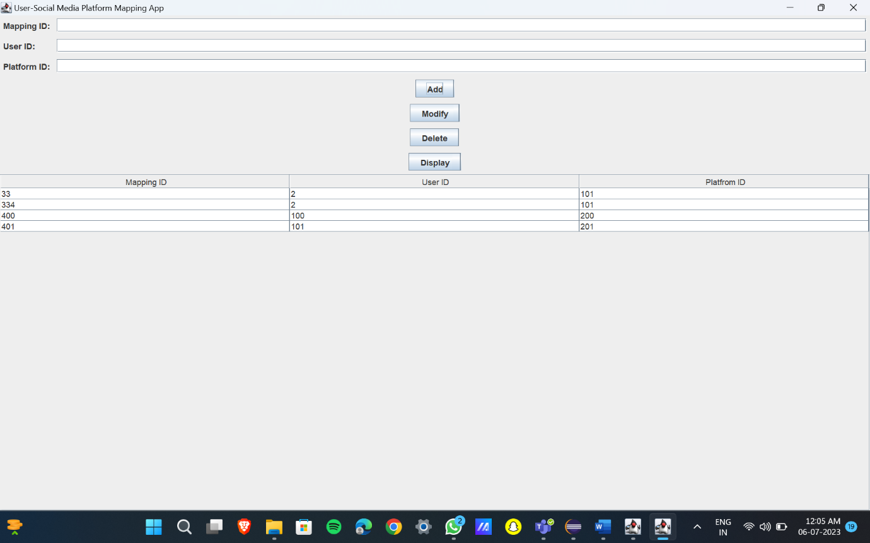

import javax.swing.*;

import javax.swing.table.DefaultTableModel;

import java.awt.*;

import java.sql.*;

import java.util.ArrayList;

import java.util.List;

public class User_social_media extends JFrame {

private JTextField txtMappingID, txtUserID, txtPlatformID;

private JTable tblMappings;

private JButton btnAdd, btnModify, btnDelete, btnDisplay;

private Connection connection;

public User_social_media() {

initializeUI();

connectToDatabase();

displayMappings();

}

private void initializeUI() {

txtMappingID = new JTextField();

txtUserID = new JTextField();

txtPlatformID = new JTextField();

tblMappings = new JTable();

tblMappings.setSelectionMode(ListSelectionModel.SINGLE_SELECTION);

tblMappings.getSelectionModel().addListSelectionListener(e -> selectMapping());

JScrollPane scrollPane = new JScrollPane(tblMappings);

btnAdd = new JButton("Add");

btnModify = new JButton("Modify");

btnDelete = new JButton("Delete");

btnDisplay = new JButton("Display");

JPanel panel = new JPanel(new GridBagLayout());

GridBagConstraints gbc = new GridBagConstraints();

gbc.gridx = 0;

gbc.gridy = 0;

gbc.anchor = GridBagConstraints.WEST;

gbc.insets = new Insets(5, 5, 5, 5);

panel.add(new JLabel("Mapping ID:"), gbc);

gbc.gridy++;

panel.add(new JLabel("User ID:"), gbc);

gbc.gridy++;

panel.add(new JLabel("Platform ID:"), gbc);

gbc.gridx = 1;

gbc.gridy = 0;

gbc.fill = GridBagConstraints.HORIZONTAL;

gbc.weightx = 1;

panel.add(txtMappingID, gbc);

gbc.gridy++;

panel.add(txtUserID, gbc);

gbc.gridy++;

panel.add(txtPlatformID, gbc);

gbc.gridx = 0;

gbc.gridy++;

gbc.gridwidth = 2;

gbc.fill = GridBagConstraints.NONE;

gbc.anchor = GridBagConstraints.CENTER;

gbc.weightx = 0;

panel.add(btnAdd, gbc);

gbc.gridy++;

panel.add(btnModify, gbc);

gbc.gridy++;

panel.add(btnDelete, gbc);

gbc.gridy++;

panel.add(btnDisplay, gbc);

setLayout(new BorderLayout());

add(panel, BorderLayout.NORTH);

add(scrollPane, BorderLayout.CENTER);

btnAdd.addActionListener(e -> insertMapping());

btnModify.addActionListener(e -> modifyMapping());

btnDelete.addActionListener(e -> deleteMapping());

btnDisplay.addActionListener(e -> displayMappings());

setTitle("User-Social Media Platform Mapping App");

pack();

setLocationRelativeTo(null);

setVisible(true);

}

private void connectToDatabase() {

String url = "jdbc:oracle:thin:@localhost:1521:xe";

String username = "Nikhil";

String password = "Nikhil";

try {

connection = DriverManager.getConnection(url, username, password);

} catch (SQLException e) {

e.printStackTrace();

}

}

private void insertMapping() {

String mappingID = txtMappingID.getText();

String userID = txtUserID.getText();

String platformID = txtPlatformID.getText();

try {

String query = "INSERT INTO user_social_media (mapping_id, user_id, platfrom_id) VALUES (?, ?, ?)";

PreparedStatement statement = connection.prepareStatement(query);

statement.setString(1, mappingID);

statement.setString(2, userID);

statement.setString(3, platformID);

statement.executeUpdate();

clearFields();

displayMappings();

} catch (SQLException e) {

e.printStackTrace();

}

}

private void modifyMapping() {

int selectedRow = tblMappings.getSelectedRow();

if (selectedRow >= 0) {

String mappingID = txtMappingID.getText();

String userID = txtUserID.getText();

String platformID = txtPlatformID.getText();

try {

String query = "UPDATE user_social_media SET user_id=?, platfrom_id=? WHERE mapping_id=?";

PreparedStatement statement = connection.prepareStatement(query);

statement.setString(1, userID);

statement.setString(2, platformID);

statement.setString(3, mappingID);

statement.executeUpdate();

clearFields();

displayMappings();

} catch (SQLException e) {

e.printStackTrace();

}

} else {

JOptionPane.showMessageDialog(this, "Please select a mapping to modify.");

}

}

private void deleteMapping() {

int selectedRow = tblMappings.getSelectedRow();

if (selectedRow >= 0) {

String mappingID = tblMappings.getValueAt(selectedRow, 0).toString();

int option = JOptionPane.showConfirmDialog(this, "Are you sure you want to delete this mapping?", "Confirmation", JOptionPane.YES_NO_OPTION);

if (option == JOptionPane.YES_OPTION) {

try {

String query = "DELETE FROM user_social WHERE mapping_id=?";

PreparedStatement statement = connection.prepareStatement(query);

statement.setString(1, mappingID);

statement.executeUpdate();

clearFields();

displayMappings();

} catch (SQLException e) {

e.printStackTrace();

}

}

} else {

JOptionPane.showMessageDialog(this, "Please select a mapping to delete.");

}

}

private void displayMappings() {

try {

String query = "SELECT * FROM user_social_media";

Statement statement = connection.createStatement();

ResultSet resultSet = statement.executeQuery(query);

List<UserSocialMediaPlatformMapping> mappings = new ArrayList<>();

while (resultSet.next()) {

String mappingID = resultSet.getString("mapping_id");

String userID = resultSet.getString("user_id");

String platformID = resultSet.getString("platfrom_id");

mappings.add(new UserSocialMediaPlatformMapping(mappingID, userID, platformID));

}

DefaultTableModel model = new DefaultTableModel();

model.setColumnIdentifiers(new String[]{"Mapping ID", "User ID", "Platfrom ID"});

for (UserSocialMediaPlatformMapping mapping : mappings) {

model.addRow(new String[]{mapping.getMappingID(), mapping.getUserID(), mapping.getPlatformID()});

}

tblMappings.setModel(model);

} catch (SQLException e) {

e.printStackTrace();

}

}

private void selectMapping() {

int selectedRow = tblMappings.getSelectedRow();

if (selectedRow >= 0) {

String mappingID = tblMappings.getValueAt(selectedRow, 0).toString();

String userID = tblMappings.getValueAt(selectedRow, 1).toString();

String platformID = tblMappings.getValueAt(selectedRow, 2).toString();

txtMappingID.setText(mappingID);

txtUserID.setText(userID);

txtPlatformID.setText(platformID);

}

}

private void clearFields() {

txtMappingID.setText("");

txtUserID.setText("");

txtPlatformID.setText("");

}

public static void main(String[] args) {

SwingUtilities.invokeLater(User_social_media::new);

}

private class UserSocialMediaPlatformMapping {

private String mappingID;

private String userID;

private String platformID;

public UserSocialMediaPlatformMapping(String mappingID, String userID, String platformID) {

this.mappingID = mappingID;

this.userID = userID;

this.platformID = platformID;

}

public String getMappingID() {

return mappingID;

}

public String getUserID() {

return userID;

}

public String getPlatformID() {

return platformID;

}

}

}

POSTS page:

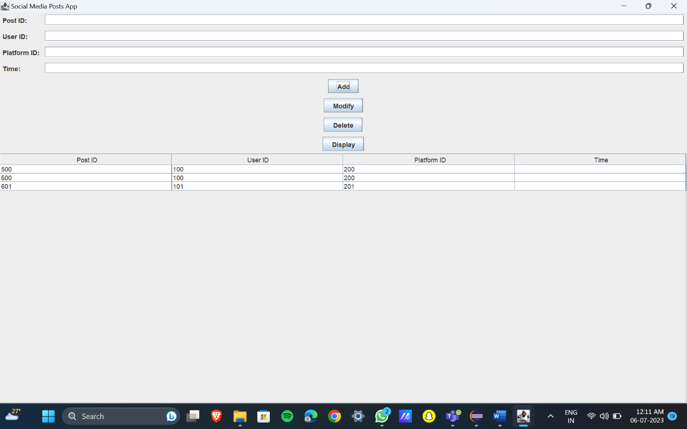

import javax.swing.*;

import javax.swing.table.DefaultTableModel;

import java.awt.*;

import java.sql.*;

import java.util.ArrayList;

import java.util.List;

public class Posts extends JFrame {

private JTextField txtPostID, txtUserID, txtPlatformID, txtTime;

private JTable tblPosts;

private JButton btnAdd, btnModify, btnDelete, btnDisplay;

private Connection connection;

public Posts() {

initializeUI();

connectToDatabase();

displayPosts();

}

private void initializeUI() {

txtPostID = new JTextField(10);

txtUserID = new JTextField(10);

txtPlatformID = new JTextField(10);

txtTime = new JTextField(10);

tblPosts = new JTable();

tblPosts.setSelectionMode(ListSelectionModel.SINGLE_SELECTION);

tblPosts.getSelectionModel().addListSelectionListener(e -> selectPost());

JScrollPane scrollPane = new JScrollPane(tblPosts);

btnAdd = new JButton("Add");

btnModify = new JButton("Modify");

btnDelete = new JButton("Delete");

btnDisplay = new JButton("Display");

JPanel panel = new JPanel(new GridBagLayout());

GridBagConstraints gbc = new GridBagConstraints();

gbc.gridx = 0;

gbc.gridy = 0;

gbc.anchor = GridBagConstraints.WEST;

gbc.insets = new Insets(5, 5, 5, 5);

panel.add(new JLabel("Post ID:"), gbc);

gbc.gridy++;

panel.add(new JLabel("User ID:"), gbc);

gbc.gridy++;

panel.add(new JLabel("Platform ID:"), gbc);

gbc.gridy++;

panel.add(new JLabel("Time:"), gbc);

gbc.gridx = 1;

gbc.gridy = 0;

gbc.fill = GridBagConstraints.HORIZONTAL;

gbc.weightx = 1;

panel.add(txtPostID, gbc);

gbc.gridy++;

panel.add(txtUserID, gbc);

gbc.gridy++;

panel.add(txtPlatformID, gbc);

gbc.gridy++;

panel.add(txtTime, gbc);

gbc.gridx = 0;

gbc.gridy++;

gbc.gridwidth = 2;

gbc.fill = GridBagConstraints.NONE;

gbc.anchor = GridBagConstraints.CENTER;

gbc.weightx = 0;

panel.add(btnAdd, gbc);

gbc.gridy++;

panel.add(btnModify, gbc);

gbc.gridy++;

panel.add(btnDelete, gbc);

gbc.gridy++;

panel.add(btnDisplay, gbc);

setLayout(new BorderLayout());

add(panel, BorderLayout.NORTH);

add(scrollPane, BorderLayout.CENTER);

btnAdd.addActionListener(e -> insertPost());

btnModify.addActionListener(e -> modifyPost());

btnDelete.addActionListener(e -> deletePost());

btnDisplay.addActionListener(e -> displayPosts());

setTitle("Social Media Posts App");

pack();

setLocationRelativeTo(null);

setDefaultCloseOperation(JFrame.EXIT_ON_CLOSE);

setVisible(true);

}

private void connectToDatabase() {

String url = "jdbc:oracle:thin:@localhost:1521:xe";

String username = "Nikhil";

String password = "Nikhil";

try {

connection = DriverManager.getConnection(url, username, password);

} catch (SQLException e) {

e.printStackTrace();

JOptionPane.showMessageDialog(this, "Failed to connect to the database.");

System.exit(1);

}

}

private void insertPost() {

String postID = txtPostID.getText();

String userID = txtUserID.getText();

String platformID = txtPlatformID.getText();

String time = txtTime.getText();

try {

String query = "INSERT INTO posts (post_id, user_id, platform_id, time) VALUES (?, ?, ?, ?)";

PreparedStatement statement = connection.prepareStatement(query);

statement.setString(1, postID);

statement.setString(2, userID);

statement.setString(3, platformID);

statement.setString(4, time);

statement.executeUpdate();

clearFields();

displayPosts();

} catch (SQLException e) {

e.printStackTrace();

JOptionPane.showMessageDialog(this, "Failed to insert the post.");

}

}

private void modifyPost() {

int selectedRow = tblPosts.getSelectedRow();

if (selectedRow >= 0) {

String postID = txtPostID.getText();

String userID = txtUserID.getText();

String platformID = txtPlatformID.getText();

String time = txtTime.getText();

try {

String query = "UPDATE posts SET user_id=?, platform_id=?, time=? WHERE post_id=?";

PreparedStatement statement = connection.prepareStatement(query);

statement.setString(1, userID);

statement.setString(2, platformID);

statement.setString(3, time);

statement.setString(4, postID);

statement.executeUpdate();

clearFields();

displayPosts();

} catch (SQLException e) {

e.printStackTrace();

JOptionPane.showMessageDialog(this, "Failed to modify the post.");

}

} else {

JOptionPane.showMessageDialog(this, "Please select a post to modify.");

}

}

private void deletePost() {

int selectedRow = tblPosts.getSelectedRow();

if (selectedRow >= 0) {

String postID = tblPosts.getValueAt(selectedRow, 0).toString();

int option = JOptionPane.showConfirmDialog(this, "Are you sure you want to delete this post?", "Confirmation", JOptionPane.YES_NO_OPTION);

if (option == JOptionPane.YES_OPTION) {

try {

String query = "DELETE FROM posts WHERE post_id=?";

PreparedStatement statement = connection.prepareStatement(query);

statement.setString(1, postID);

statement.executeUpdate();

clearFields();

displayPosts();

} catch (SQLException e) {

e.printStackTrace();

JOptionPane.showMessageDialog(this, "Failed to delete the post.");

}

}

} else {

JOptionPane.showMessageDialog(this, "Please select a post to delete.");

}

}

private void displayPosts() {

try {

String query = "SELECT * FROM posts";

Statement statement = connection.createStatement();

ResultSet resultSet = statement.executeQuery(query);

List<SocialMediaPost> posts = new ArrayList<>();

while (resultSet.next()) {

String postID = resultSet.getString("post_id");

String userID = resultSet.getString("user_id");

String platformID = resultSet.getString("platform_id");

String time = resultSet.getString("time");

posts.add(new SocialMediaPost(postID, userID, platformID, time));

}

DefaultTableModel model = new DefaultTableModel();

model.setColumnIdentifiers(new String[]{"Post ID", "User ID", "Platform ID", "Time"});

for (SocialMediaPost post : posts) {

model.addRow(new String[]{post.getPostID(), post.getUserID(), post.getPlatformID(), post.getTime()});

}

tblPosts.setModel(model);

} catch (SQLException e) {

e.printStackTrace();

JOptionPane.showMessageDialog(this, "Failed to fetch posts.");

}

}

private void selectPost() {

int selectedRow = tblPosts.getSelectedRow();

if (selectedRow >= 0) {

String postID = tblPosts.getValueAt(selectedRow, 0).toString();

String userID = tblPosts.getValueAt(selectedRow, 1).toString();

String platformID = tblPosts.getValueAt(selectedRow, 2).toString();

String time = tblPosts.getValueAt(selectedRow, 3).toString();

txtPostID.setText(postID);

txtUserID.setText(userID);

txtPlatformID.setText(platformID);

txtTime.setText(time);

}

}

private void clearFields() {

txtPostID.setText("");

txtUserID.setText("");

txtPlatformID.setText("");

txtTime.setText("");

}

public static void main(String[] args) {

SwingUtilities.invokeLater(Posts::new);

}

}

class SocialMediaPost {

private String postID;

private String userID;

private String platformID;

private String time;

public SocialMediaPost(String postID, String userID, String platformID, String time) {

this.postID = postID;

this.userID = userID;

this.platformID = platformID;

// this.time = time;

}

public String getPostID() {

return postID;

}

public String getUserID() {

return userID;

}

public String getPlatformID() {

return platformID;

}

public String getTime() {

return time;

}

}

TESTING

USERS page

Before insertion :

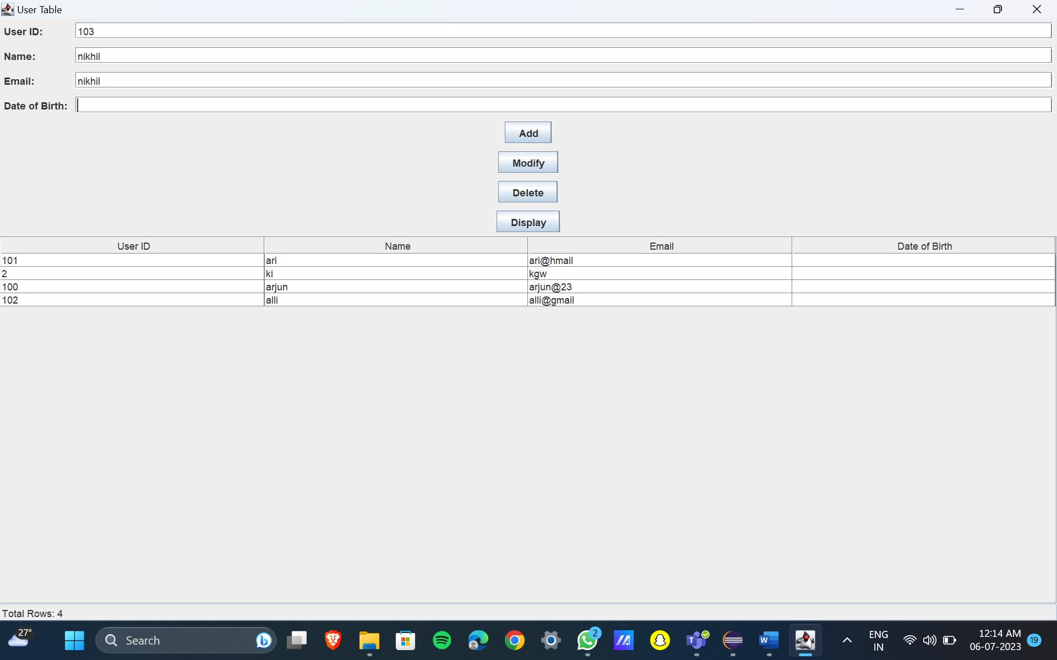

After insertion:

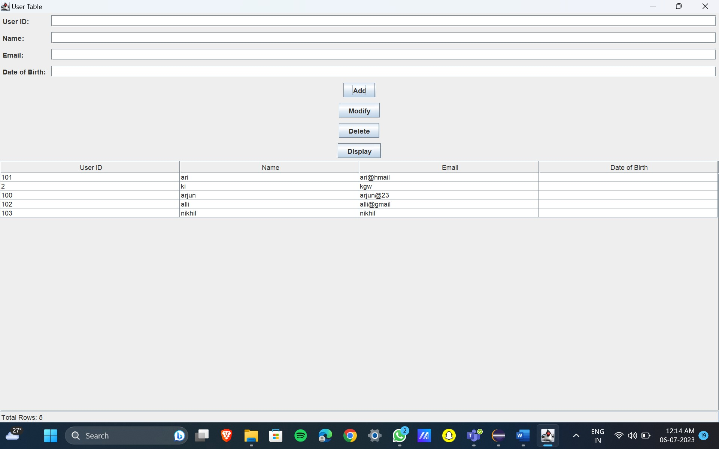

Modification:

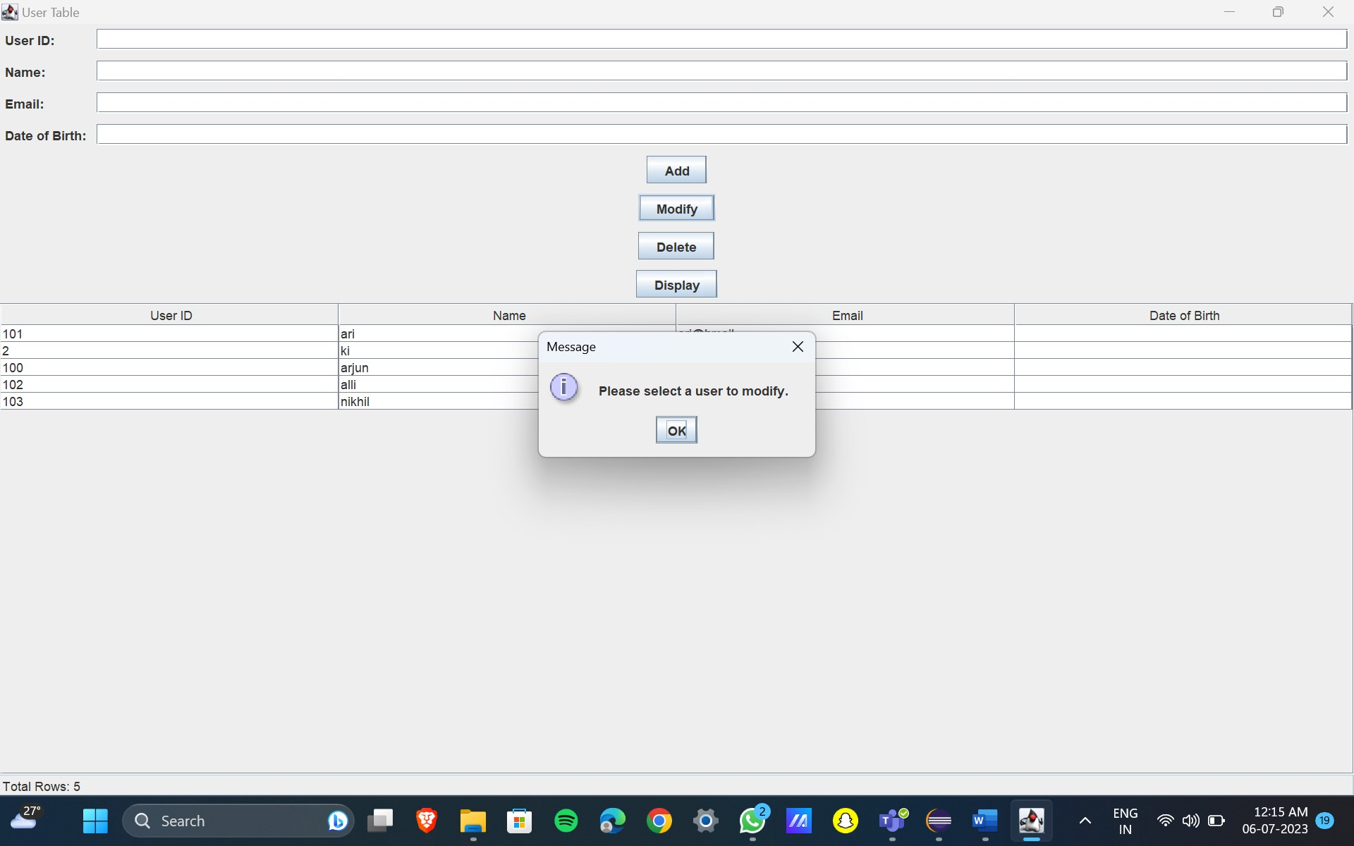

Deletion:

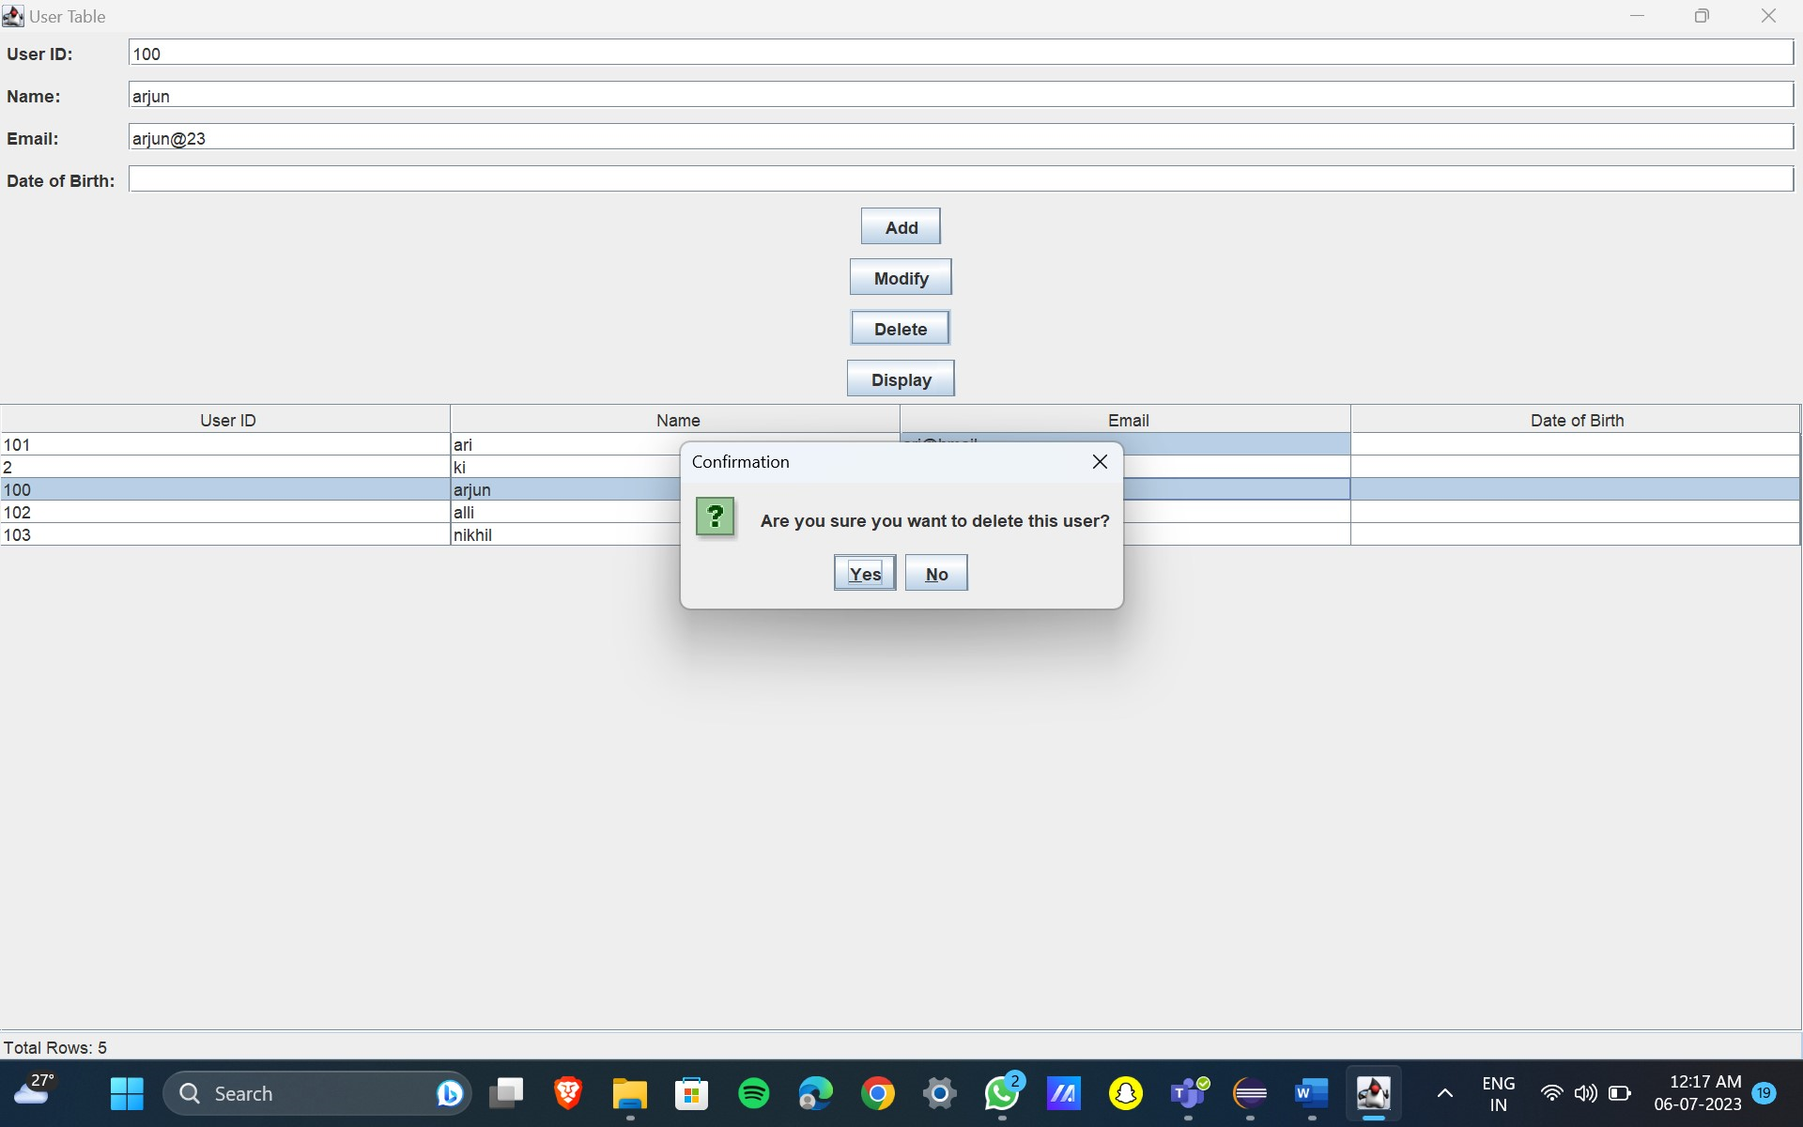

PLATFORMS page:

Before Insertion :

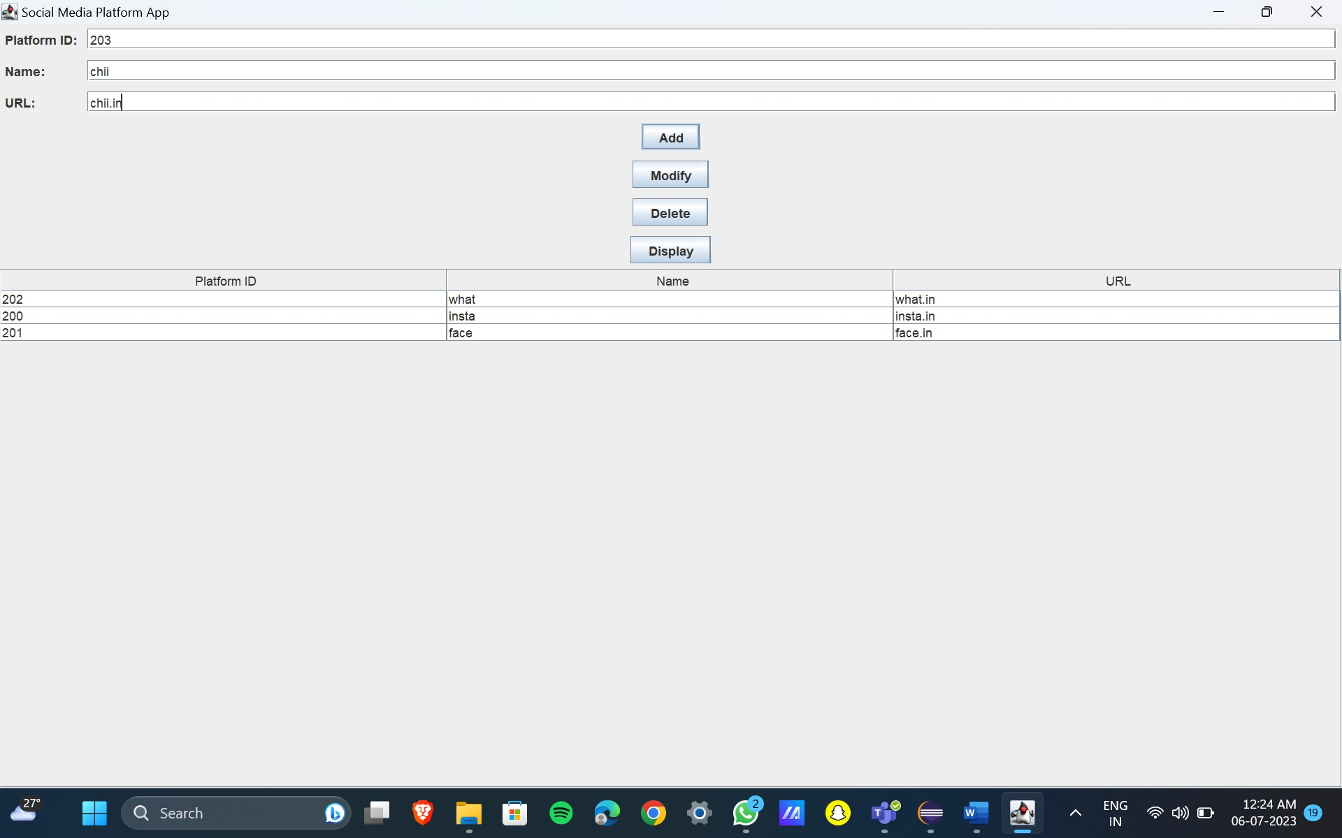

After Insertion:

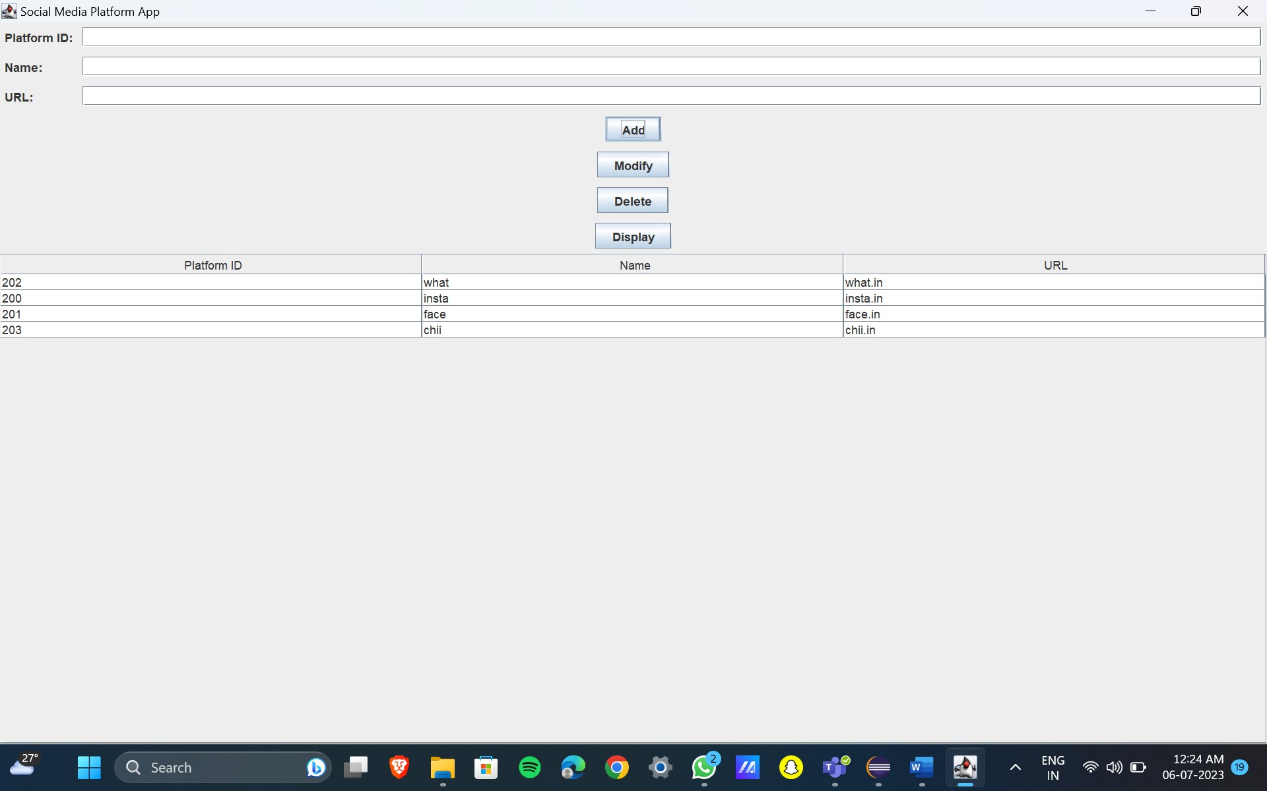

Deletion:

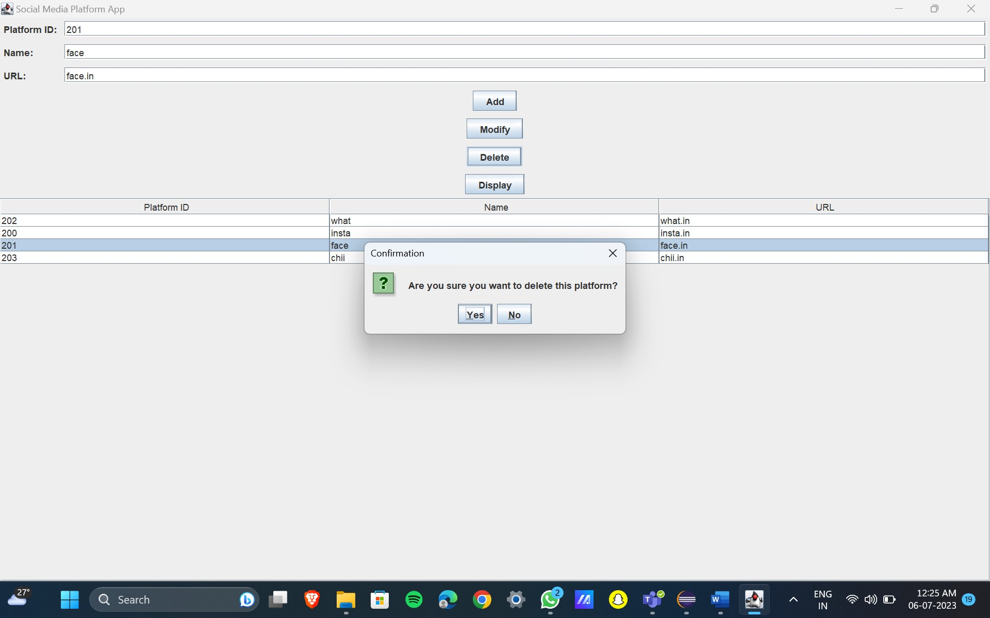

Modification:

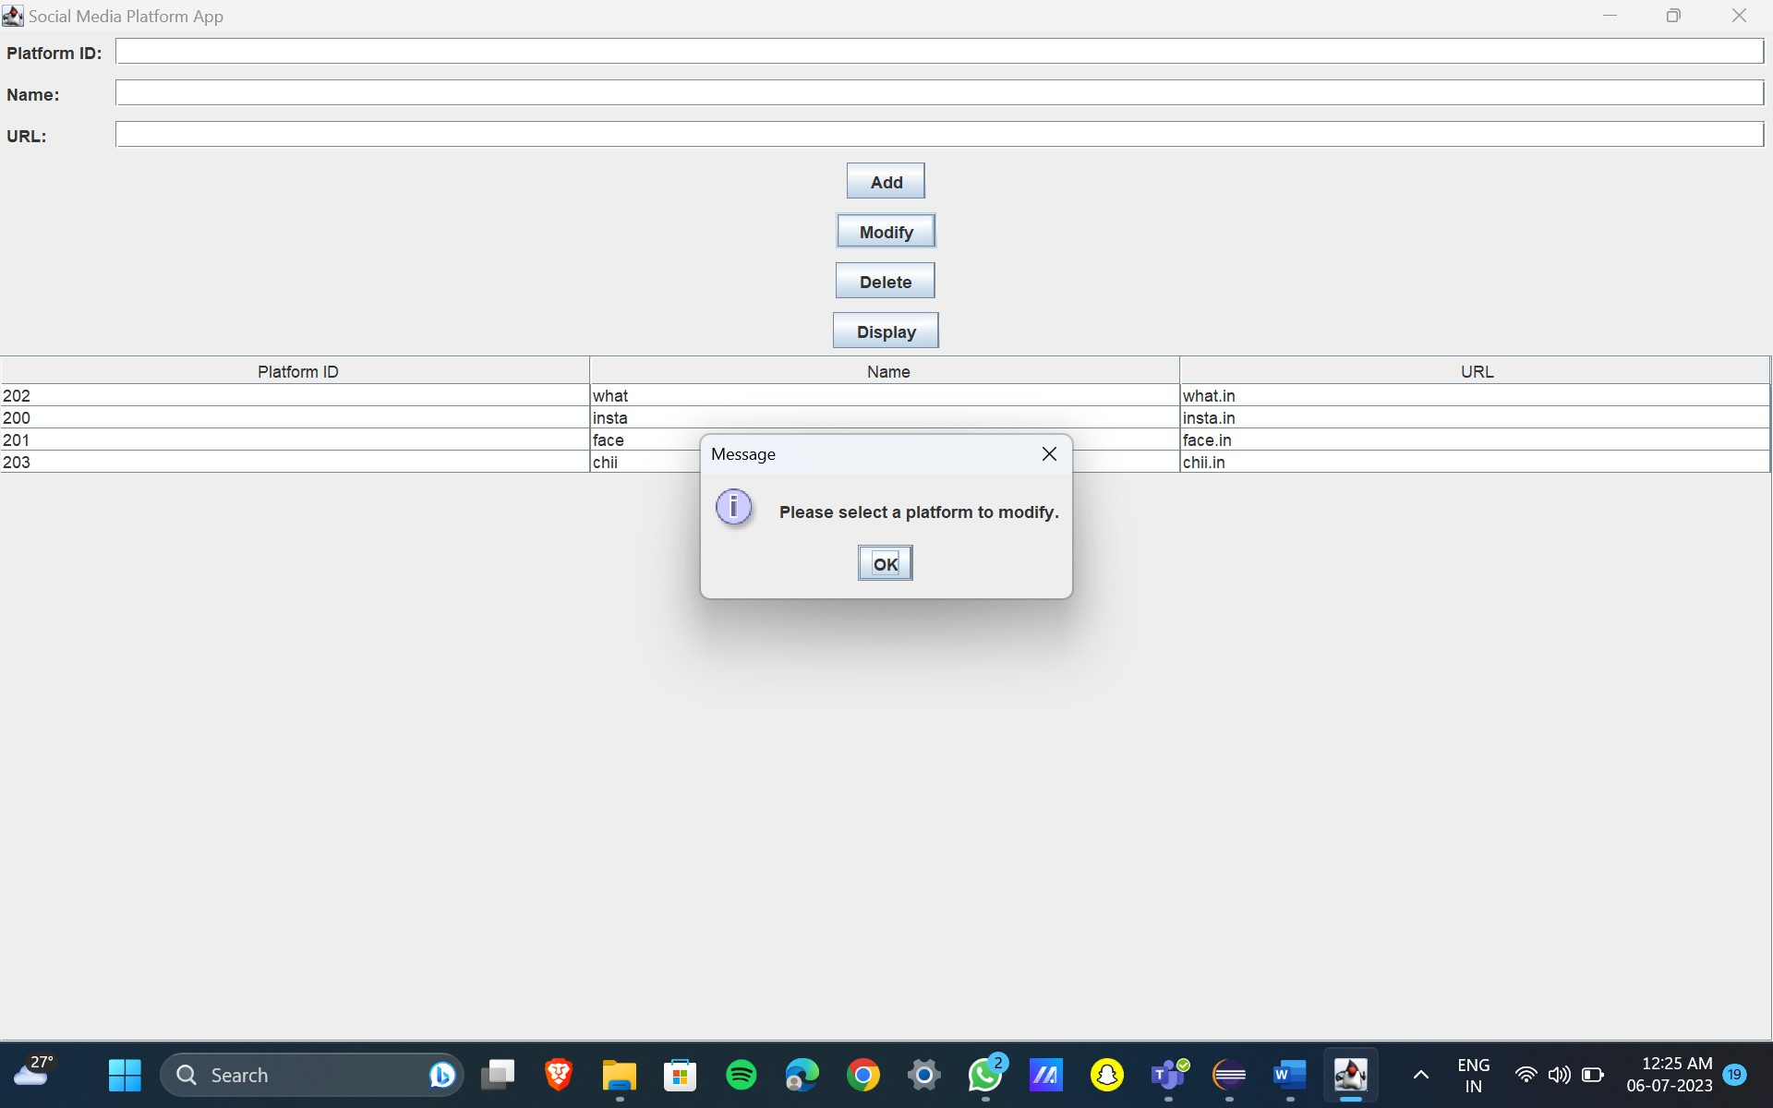

Third page:

Before Insertion :

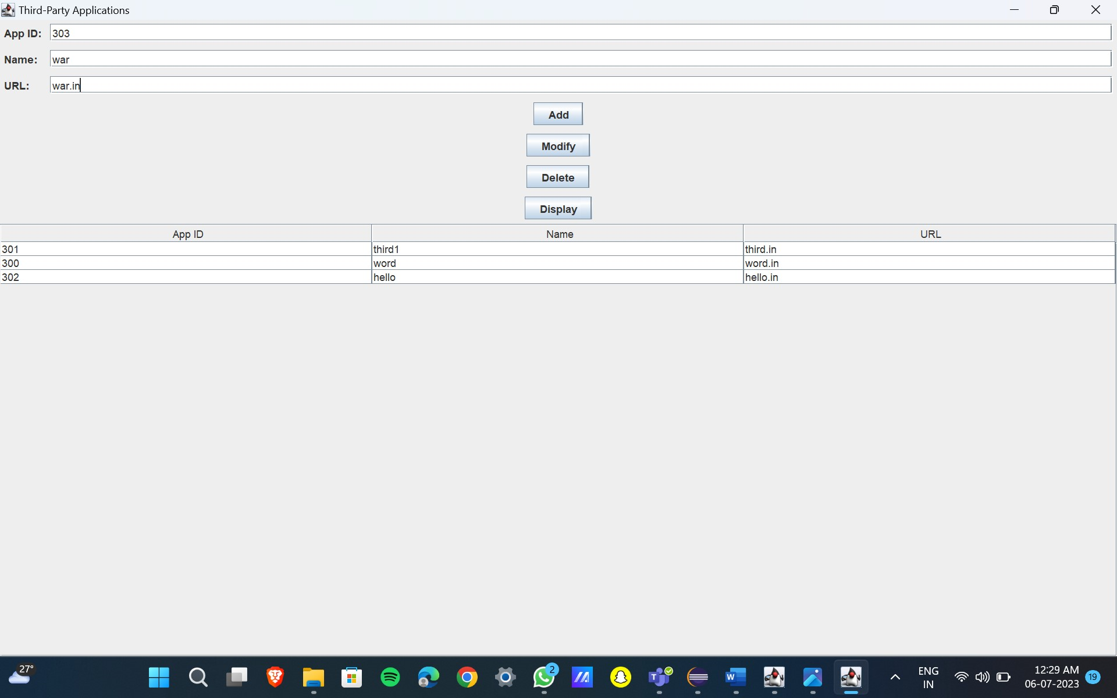

After Insertion:

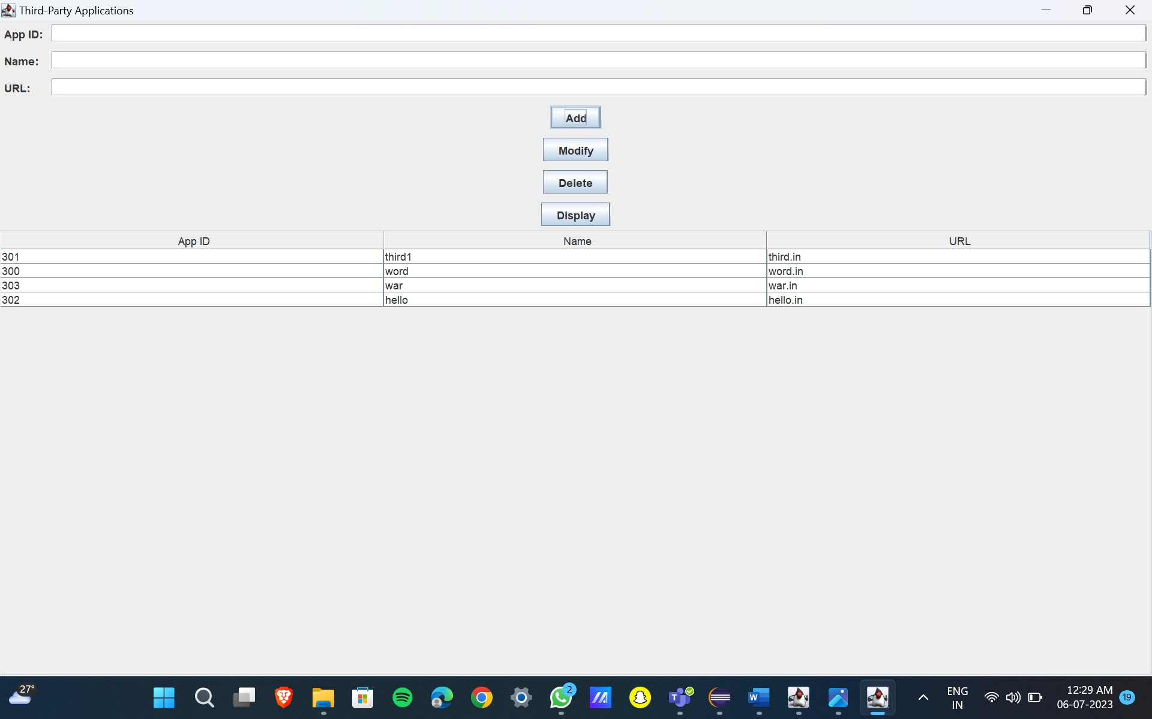

Deletion:

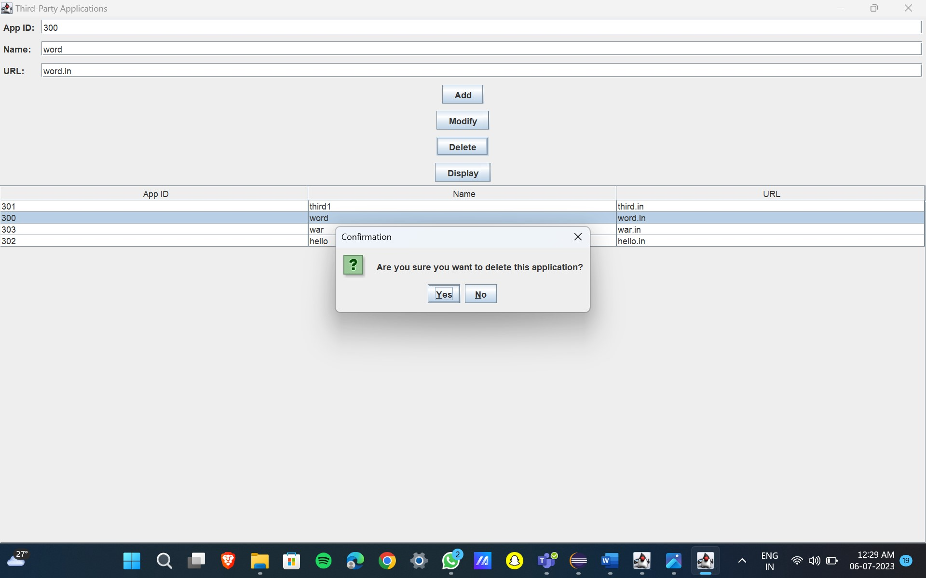

Modification:

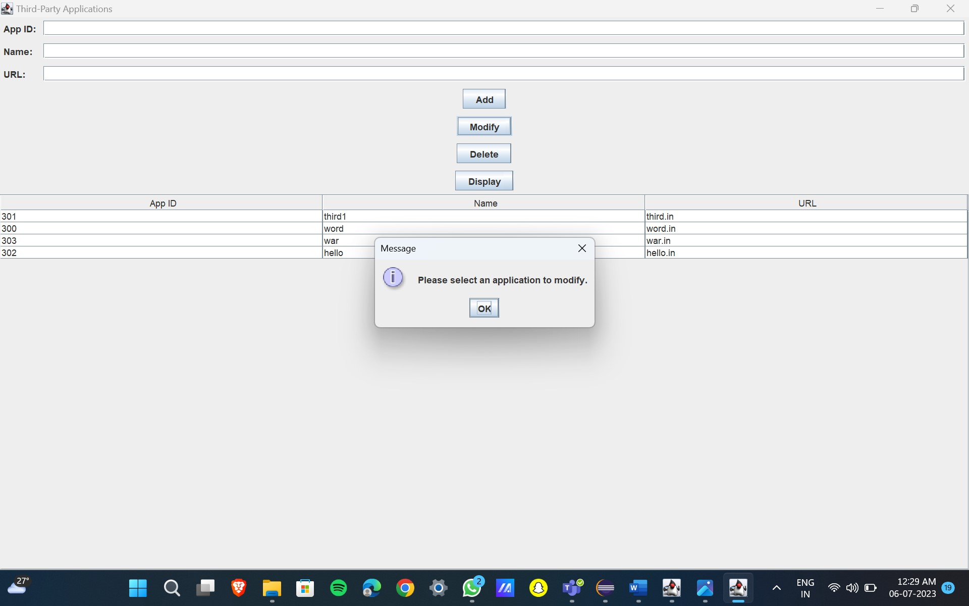

Users social media:

Before Insertion :

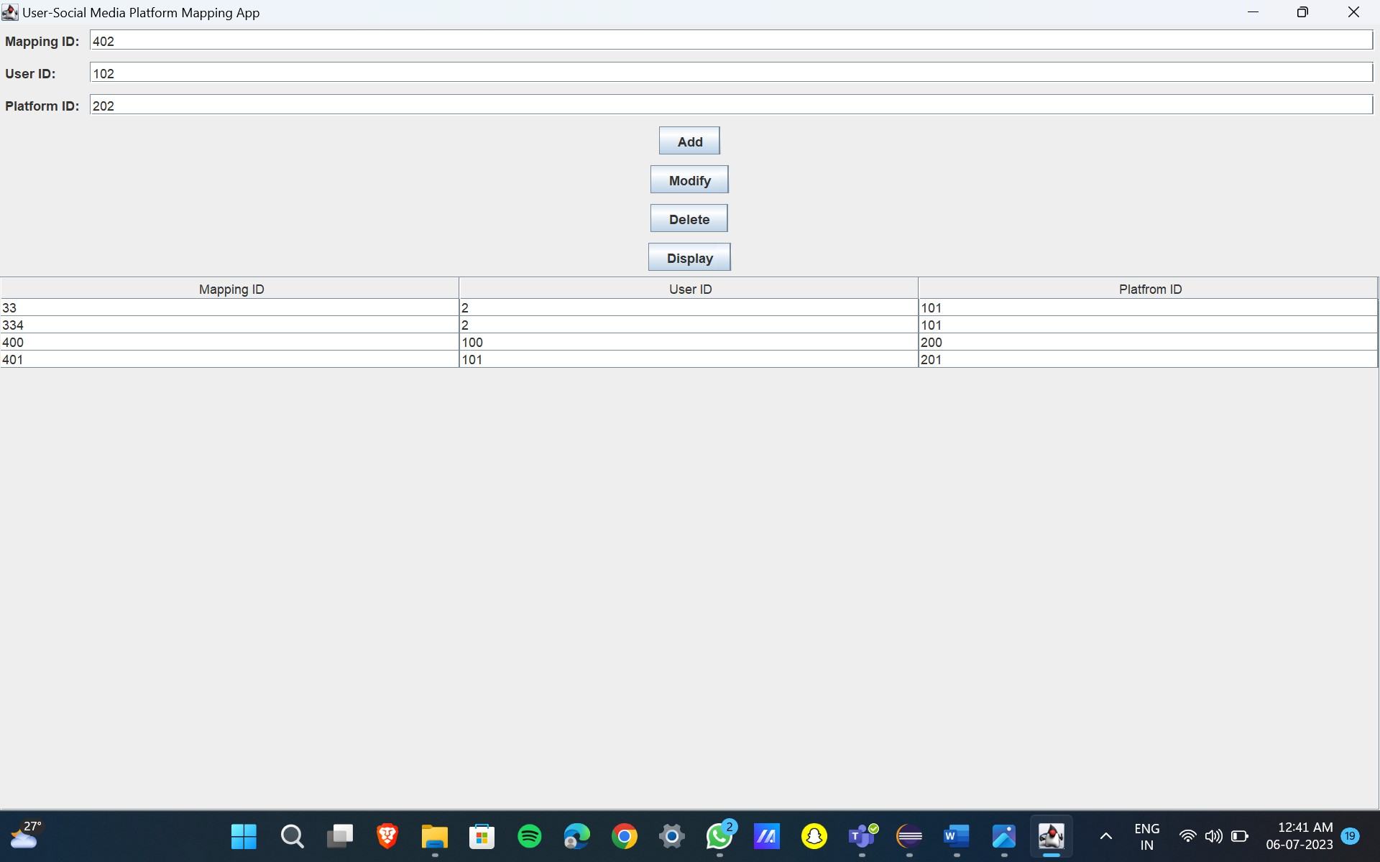

After Insertion:

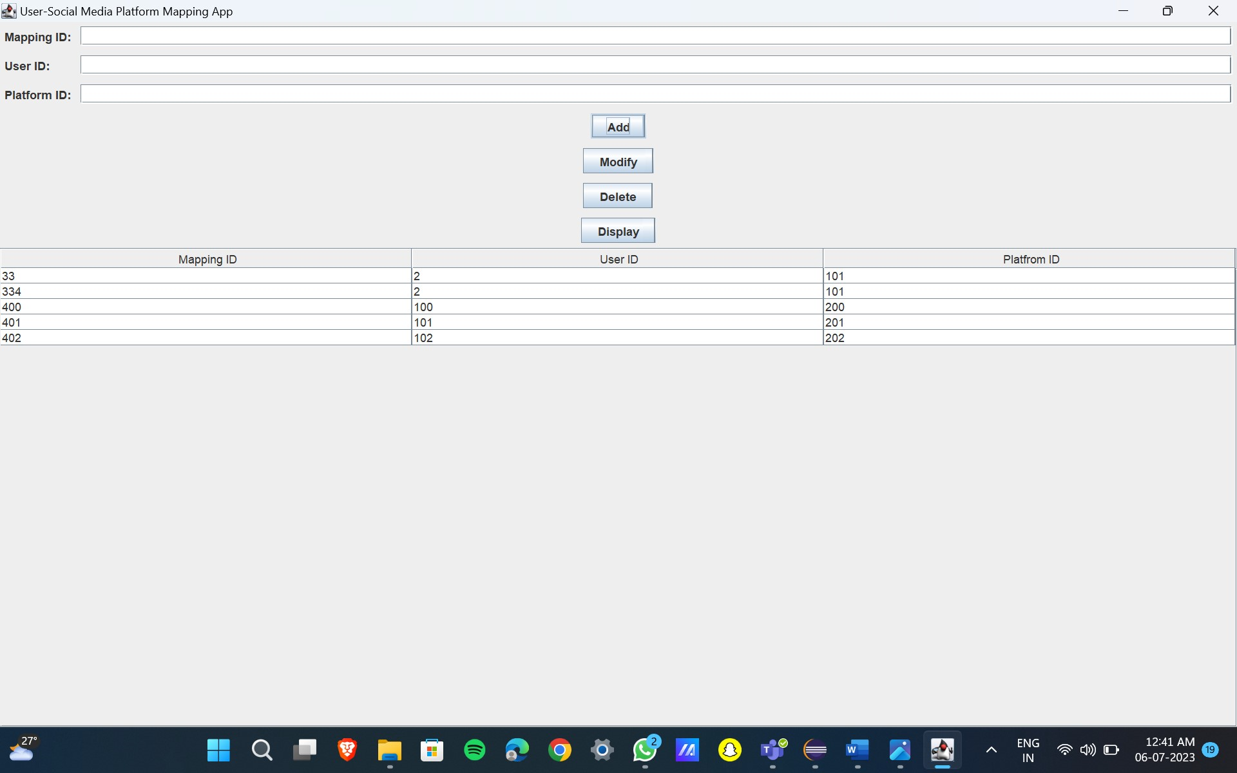

Deletion:

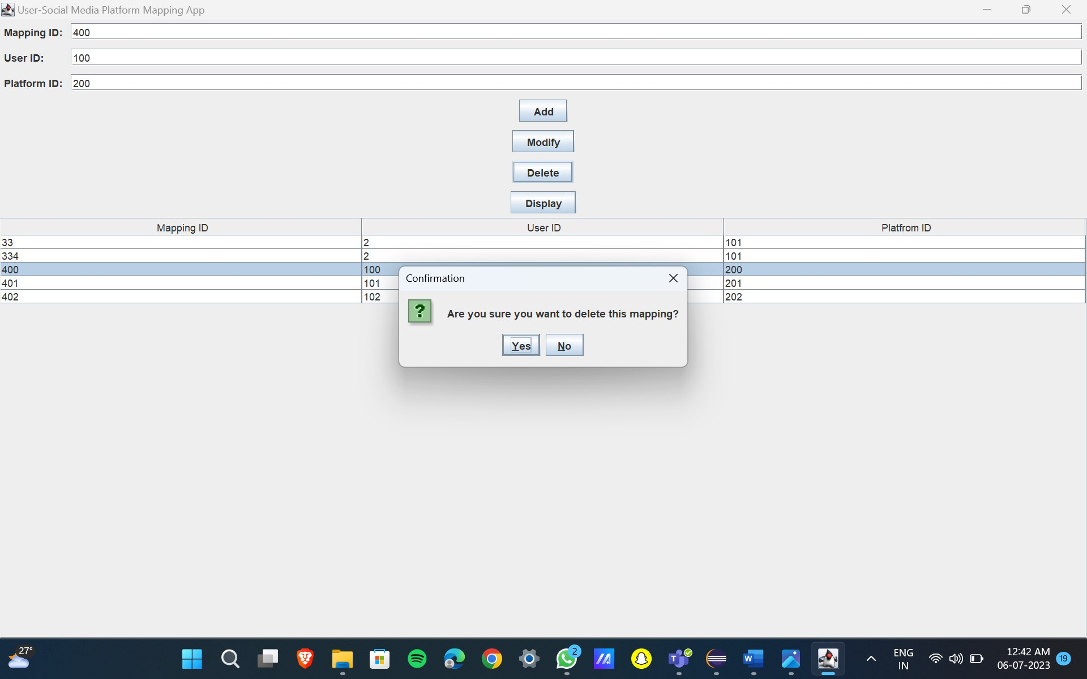

Modification:

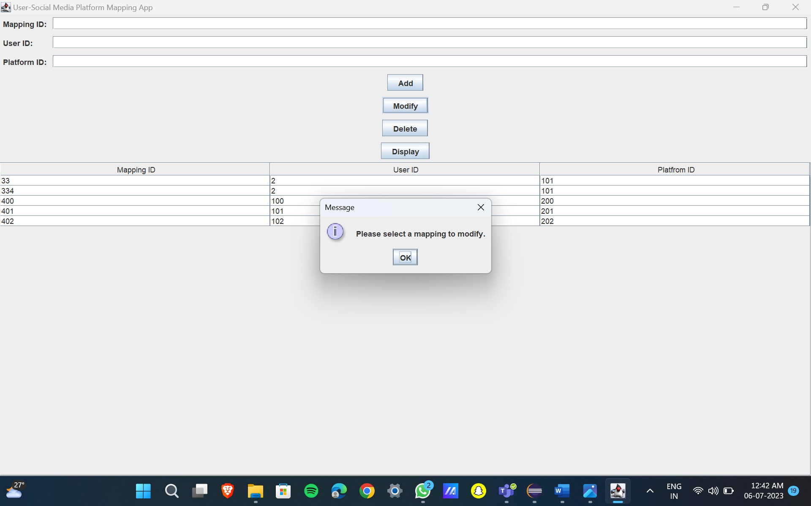

Posts:

Before Insertion :

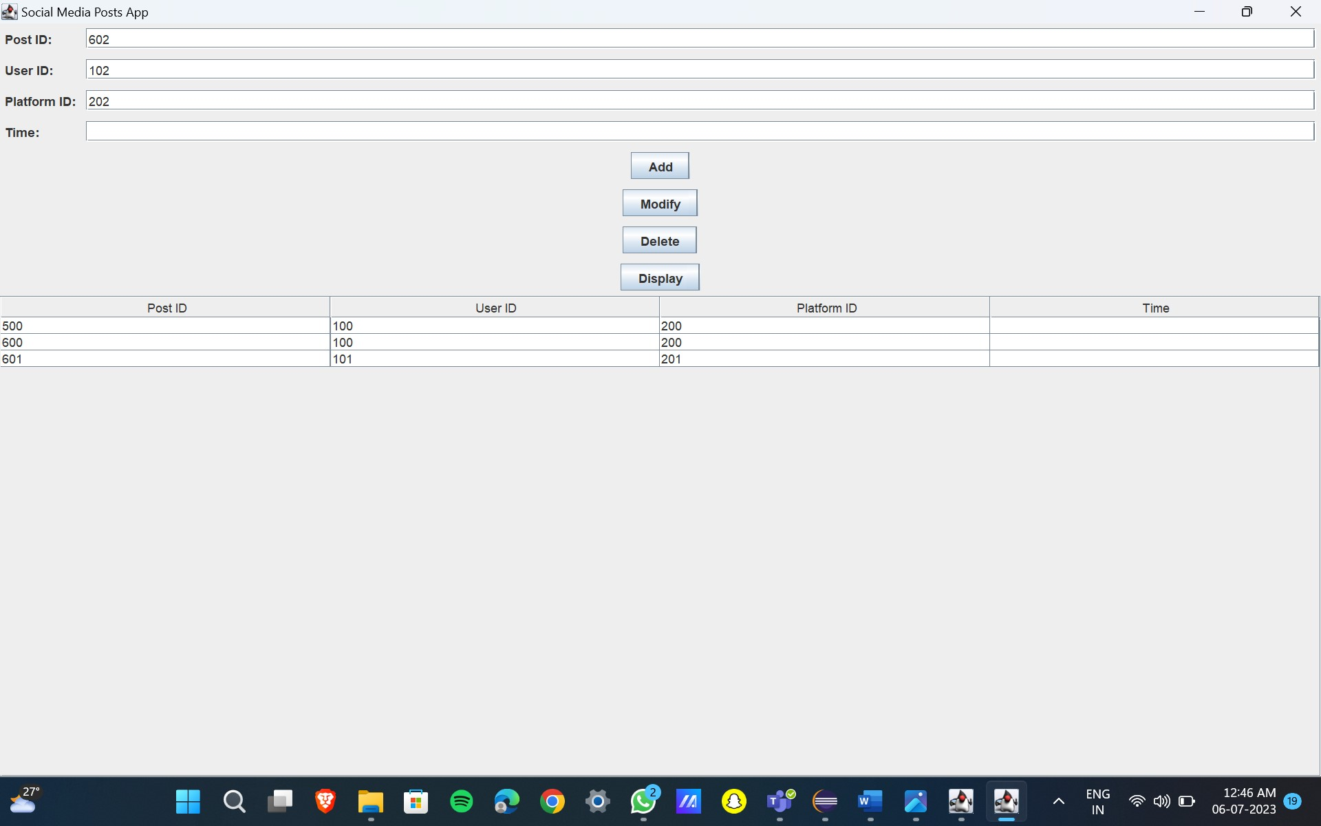

After Insertion:

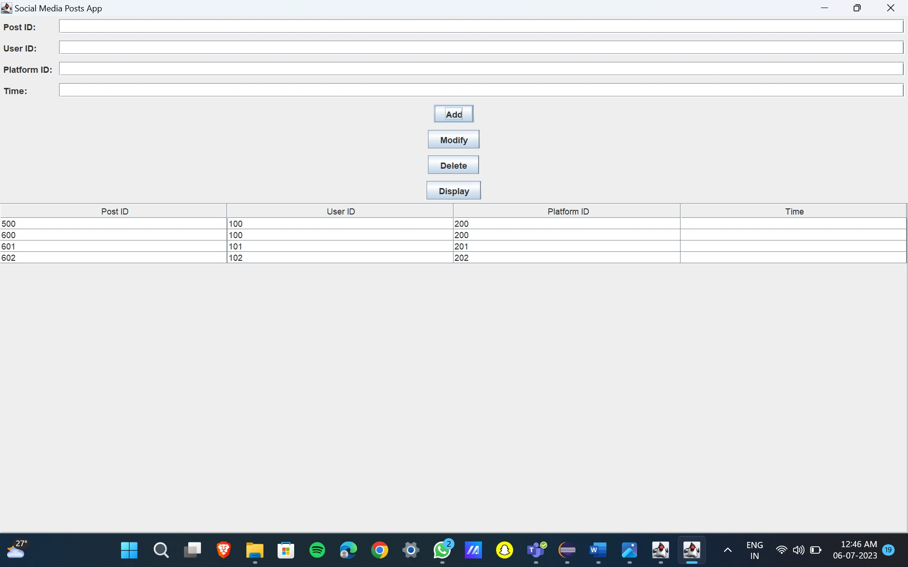

Deletion:

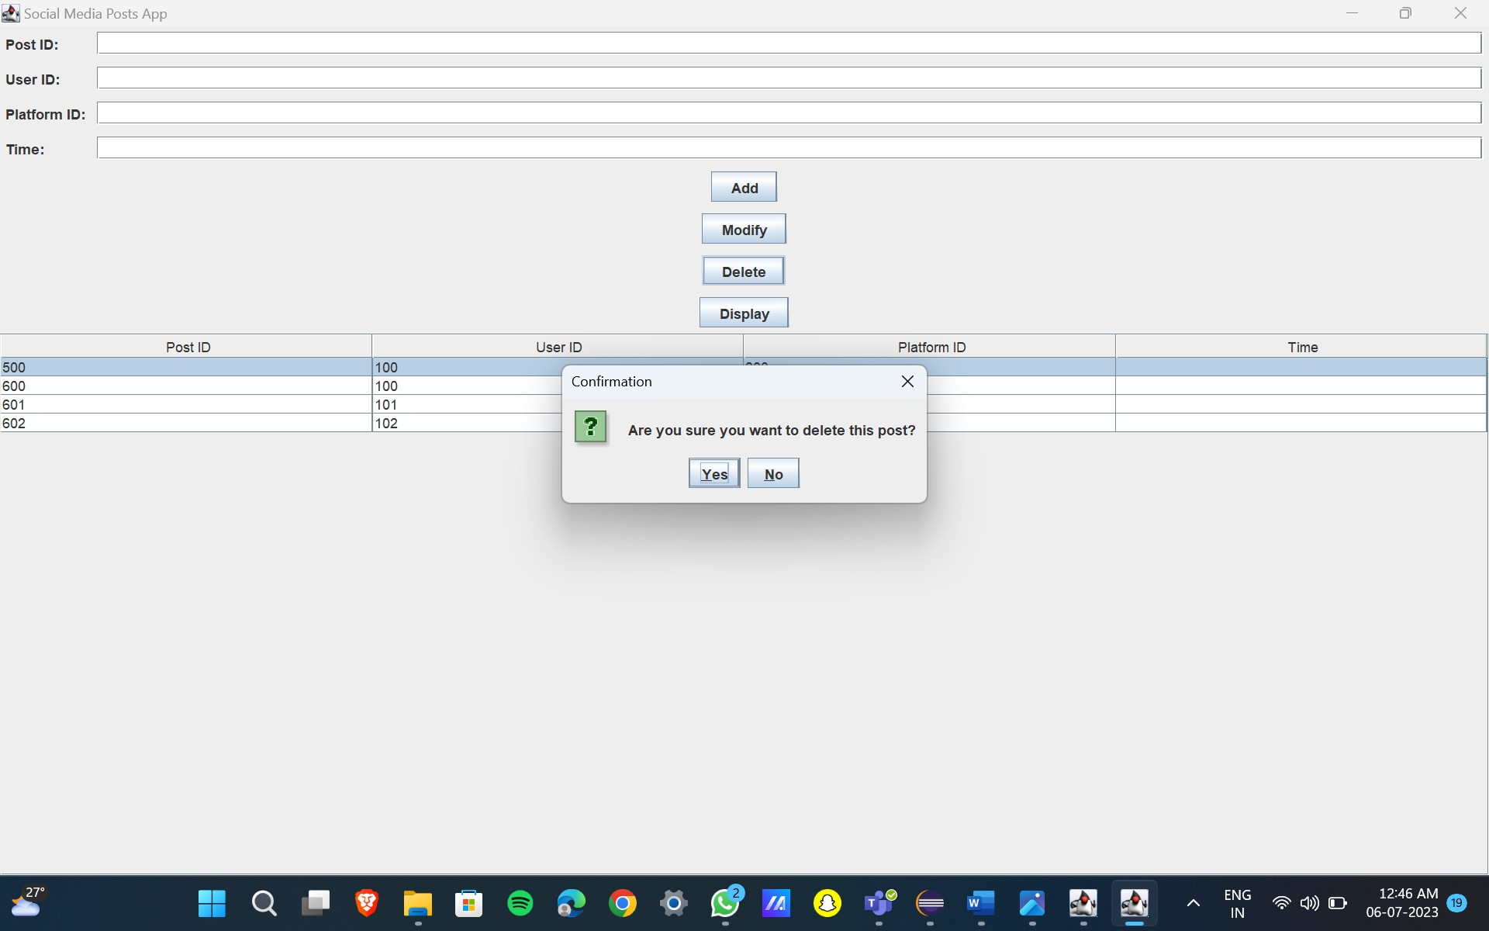

Modification:

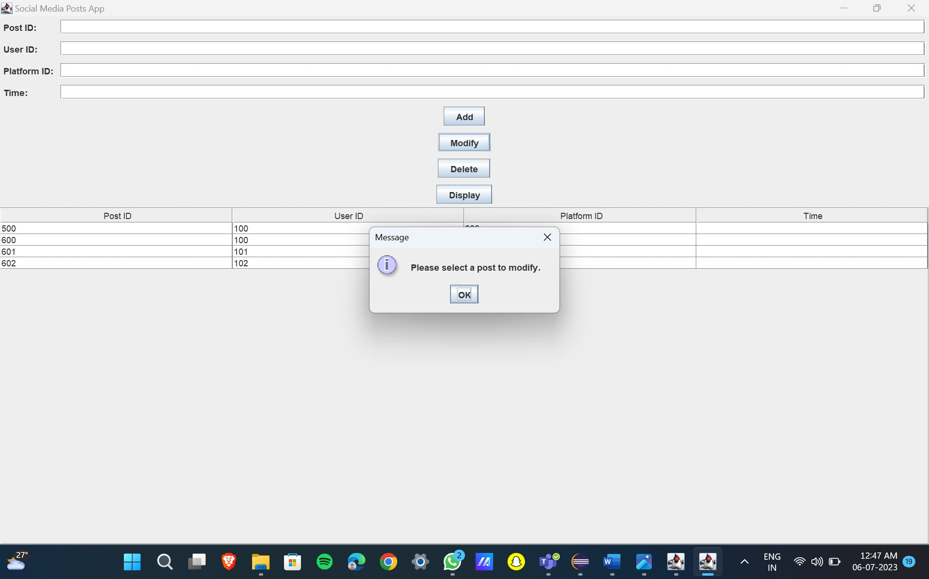

RESULT

I have successfully completed my DBMS project ‘’ LayeringOfSocialNetworkingAccount’.

**DISCUSSION AND FUTURE WORK**

The future scope of "Layering of Social Networking Account" is very promising. As social media platforms continue to evolve, there will be a growing need for users to be able to control their online presence in a more granular way. Layering of social networking accounts allows users to create multiple accounts, each with its own set of privacy settings and permissions. This can be useful for a variety of purposes, such as:

* Protecting personal information. Users can create a separate account for work or school that only contains professional-related information. This can help to keep personal information separate from work or school life.
* Managing different personas. Users can create different accounts for different aspects of their life, such as their personal life, their professional life, or their hobbies. This can help to keep different aspects of their life separate and organized.
* Targeted marketing. Businesses can use layering of social networking accounts to target their marketing messages to specific groups of people. For example, a business could create a separate account for each of its target demographics.

In the future, layering of social networking accounts is likely to become even more popular as users become more aware of the importance of privacy and control over their online presence. There are a number of companies that are already developing tools and services to help users manage their social media accounts in a more granular way. As these tools and services become more widely available, layering of social networking accounts is likely to become the norm.

**References**

● https://docs.oracle.com/javase/7/docs/api/

● https://www.javatpoint.com/java-swing

● <https://stackoverflow.com/>

**Git-Hub LINK:**

[**https://github.com/Nikhilkeetha08/LAYERING-OF-SOCIAL-MEDIA-ACCOUNTS-**](https://github.com/Nikhilkeetha08/LAYERING-OF-SOCIAL-MEDIA-ACCOUNTS-)